|  |  |  |  |  |  |  |  |
| --- | --- | --- | --- | --- | --- | --- | --- |
| Submission Coversheet | | | |  |  |  |  |
|  |  |  |  |  |  |  |  |
| **Student ID Number**  *(Do not include student name as anonymous marking is implemented)* | Radu Garaz / GAR19472838 | | | | | | |
| **Programme Title** | Computing Technologies Extended Degree (QA) | | | | | | |
| **Module Title** | Cloud Computing | | | | | | |
| **Module Code** *(listed on Moodle and in LTAFP)* | QAC020N254S | | | | | | |
| **Module Convenor** |  | | | | | | |
| **Coursework Title** | Assignment 1 | | | | | | |
| **Academic Declaration:**  *Students are reminded that the electronic copy of their essay may be checked, at any point during their degree, with Turnitin or other plagiarism detection software for plagiarised material.* | | | | | | | |
| **Word Count** |  | | | **Date Submitted** | |  | |
|  |  | | |  | |  | |
| Please save your file as:  student id_module code_module_title_assessment name  for example: COR15416549_QAB020N592S_Managing Organisations)_Essay 1 Teamwork | | | | | | | |

## Table of Contents

Table of Contents 2

Task 1: Identity and Management (IAM) Services: 3

Creating Users in Amazon: 4

Root Account: 5

IAM User: 6

Security Key Pairs for Current Environment: 19

Connecting the Keypairs to Current Application Instance 22

Task 2: Amazon Relational Database (RDS) 26

Creating RDS in AWS 27

Task 3: 28

Amazon SageMaker 28

Amazon Redshift 29

Amazon CloudSearch 30

Benefits 30

Amazon guardDuty 32

Threat severity degrees for green prioritization 32

Threat reaction and remediation automation 33

Highly to be had danger detection 33

Deploying the New Application version 34

References: 37

# Task 1: Identity and Management (IAM) Services:

IAM includes identity management and access control services. AWS IAM reduces the effort, cost and time to help users more efficiently manage their identity data.

For every business need an IAM service is there to provide it with a solution. It can be used for user management, access management, identity and credential management and more. AWS Identity and Management Services are built on industry standard protocols with the customer in mind.

For the customers the benefits of AWS IAM are clear - improved access control and simpler administration tasks, increased security through global visibility on their use of encryption and availability through single sign-on offerings. By using SAML SSO, companies ensure that any web app is only ever bothering to login a single time before gaining full access to other web apps inside their firm’s network without additional authentication processes. Through this they get fast browsing as they won’t have to fill out new login forms each time, they want to see something else inside.

Elastic Beanstalk is an AWS product that lets developers deploy and manage websites running on Amazon EC2 products. Elastic Beanstalk provides a platform for managing servers, application configuration, and data persistence. With this service, developers don't need to manually configure the underlying EC2 resources or access to their codebase. It does all these things automatically, so long as the developer can upload their application code and the specified configuration information up front. Their storage and computing services have become an essential ingredient for business success.

Amazon Web Services has a tool that companies can use to generate secure key pairs when they store data in the cloud. Key pair is an asymmetrical cryptographic process that used a public key and a private key. Public keys are used to encrypt the data and public keys can be shared (public-key cryptography). Private keys are used to decrypt the data and the private keys should not be shared with anyone who doesn't have permission (private-key cryptography). Every time you talk over your public key, you create new symmetrical session keys, meaning your data is always encrypted with a session key credit card information is encrypted by using this encryption process to prevent unauthorized access or messages from being intercepted on its way from one person to another. IAM policies can be easy to set up and make managing access very straightforward with AWS permissions. When there are many IAM users, granular control per IAM user can allow a policy to have least access necessary. There is also one-time approval code that can be given to the user via phone or email which would require no biometrics or device before granting them access.

The Amazon AMI is a service provided by Amazon Web Services. This service is used for creating AMI’S for EC2 Instances. An AMI (Amazon Machine Image) is a disk image, which can be used to start a new EC2 instance. This image can be created from a snapshot of a running EC2 image. This AMI can be launched from the command line or through a web interface. This is a very useful service for developers who wish to create their own AMI.

## Creating Users in Amazon:

In amazon, there are two kinds of account can be created. First of a Root account is required which has no restriction to perform operations. Secondly, IAM Identity and Management

While creating an AWS account, it begins with a single-clicked sign-in authentication that has overall access without any restrictions to all AWS services, operations and resources. This authentication is called account root user and is accessed by signing in with the email address and password that you used to create the account.

## Root Account:

The root account has full access to all the resources inside the AWS account. With the root user credentials, anything inside the AWS account can be accessed.

The root user can be logged in by simply entering the Email and the password on login page. AWS frequently ask to fill the Captcha as security purpose.

Logging in the Root Account:

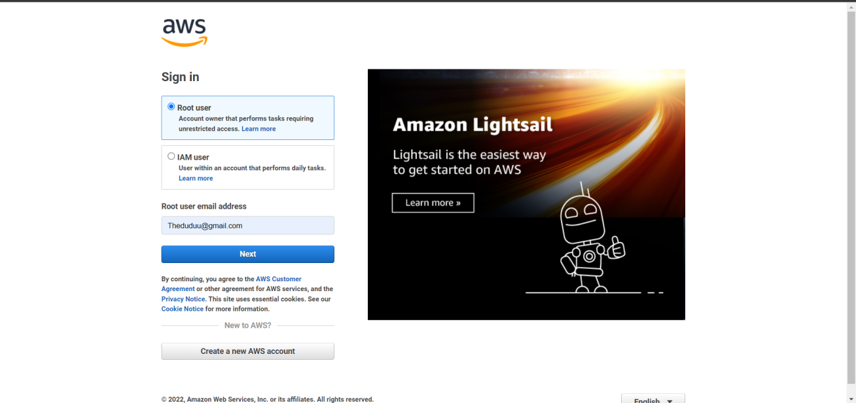

Screenshot: 1: Login

After successful login, A Root user dashboard is appeared:

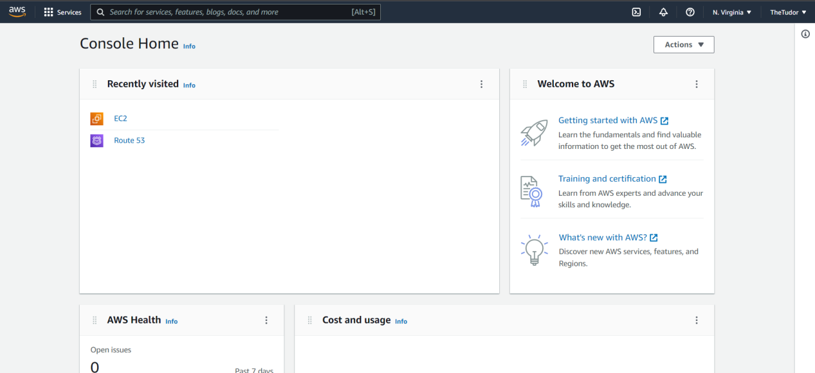

Screenshot: 2: Dashboard

## IAM User:

IAM user are the user who performs the daily tasks under the restrictions enforced by the root user. There can be many IAM users for different tasks such as Seller, Manager, or based on the department.

Here, Now will create 3 different IAM users for managing the website’s daily tasks:

* John as Administrator
* Doe as Administrator
* Wick as Sales

First, all the users will be created and then they will be assigned their roles.

After login to the dashboard, access the IAM services from the dashboard and click on it.

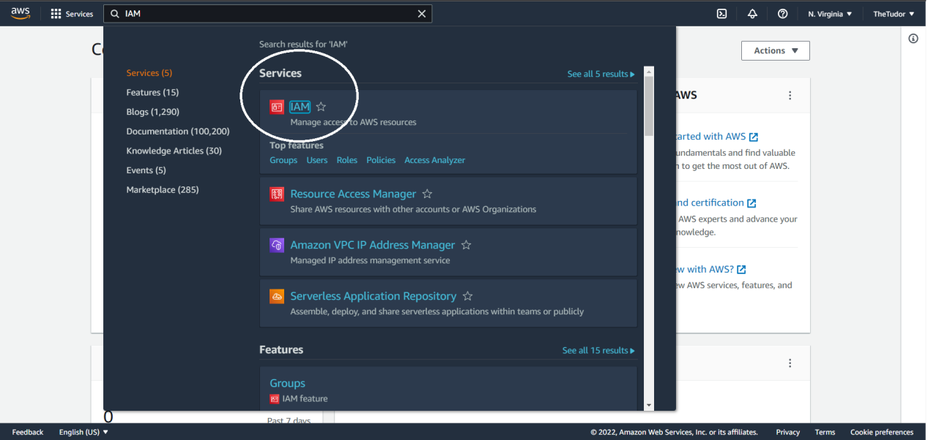

Screenshot: 3: IAM service

Till now, NO user is created:

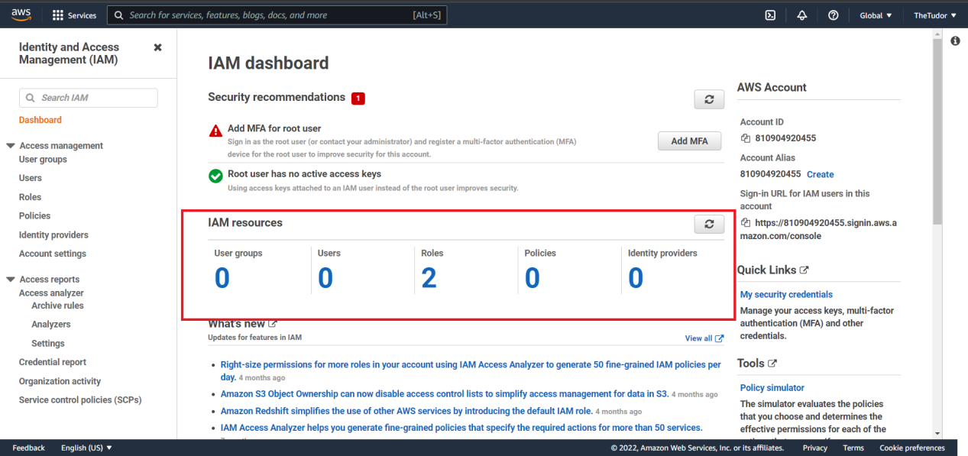

Screenshot: 4: IAM user Dashboard

Click to users’ option from left sidebar: and then Add User

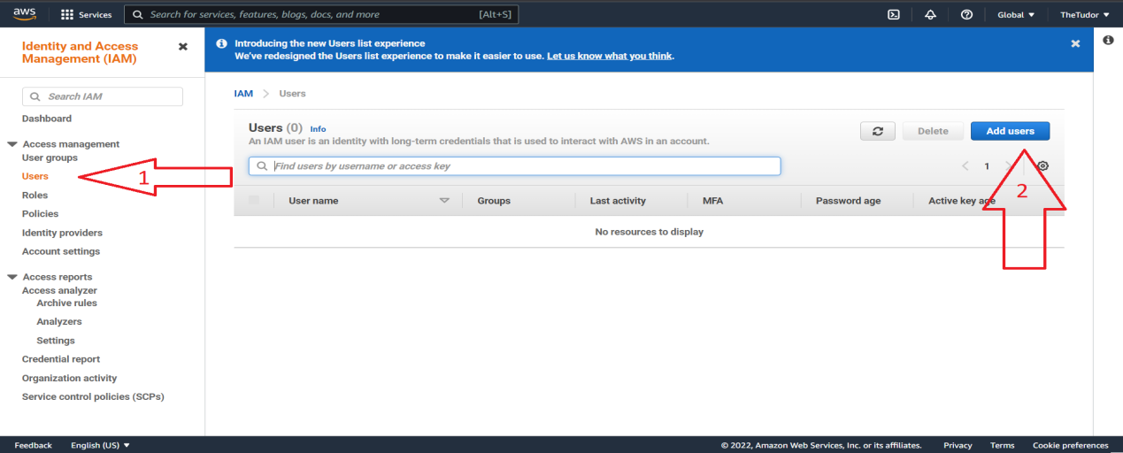

Screenshot: 5: Add users

Add usernames:

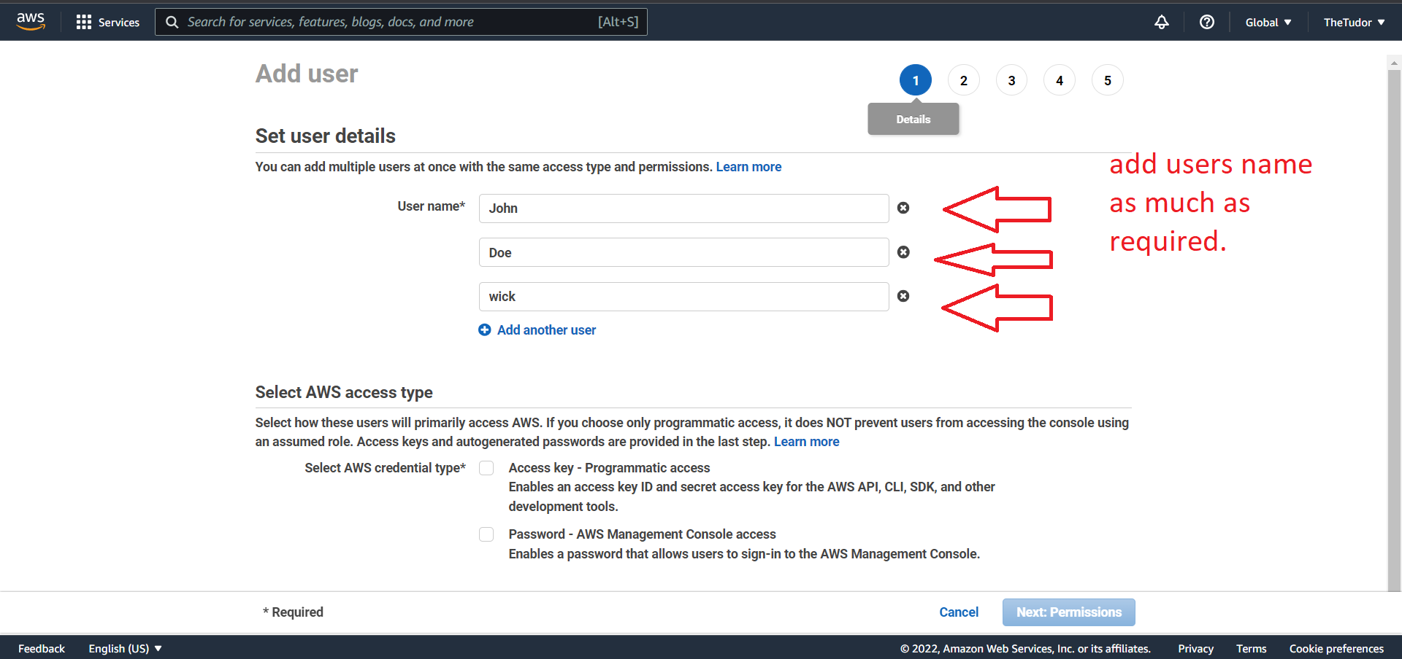

Screenshot: 6: Add User Names

Check the: “**Password - AWS Management Console access”.**

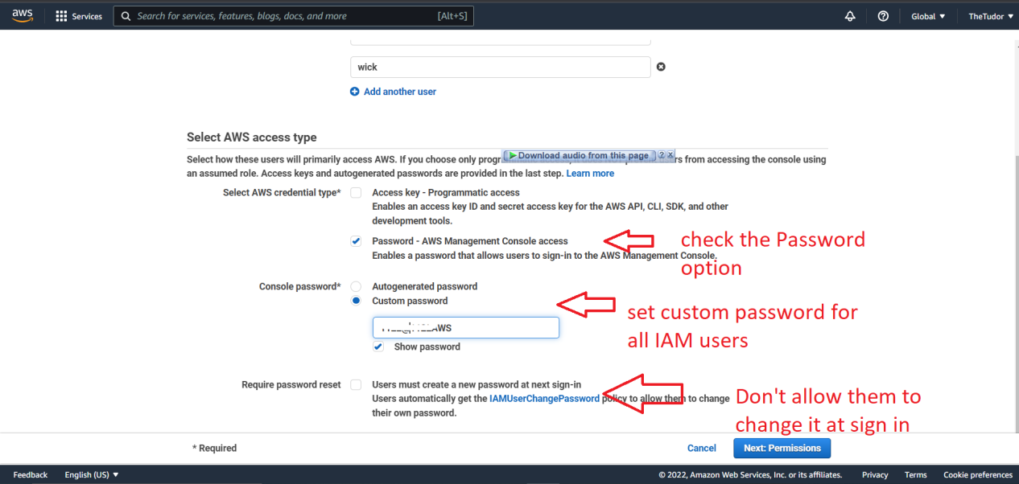

Screenshot: 7: Applying Security Password

Now, user role will be assigned

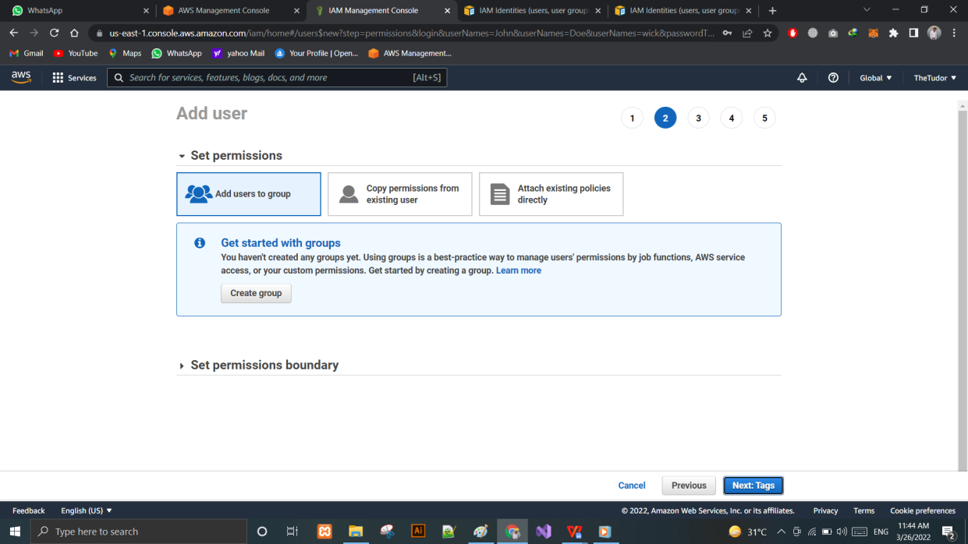

Screenshot: 8: Permissions

Here in step 5: A URL will be appeared that can be used to login to the AWS Services.

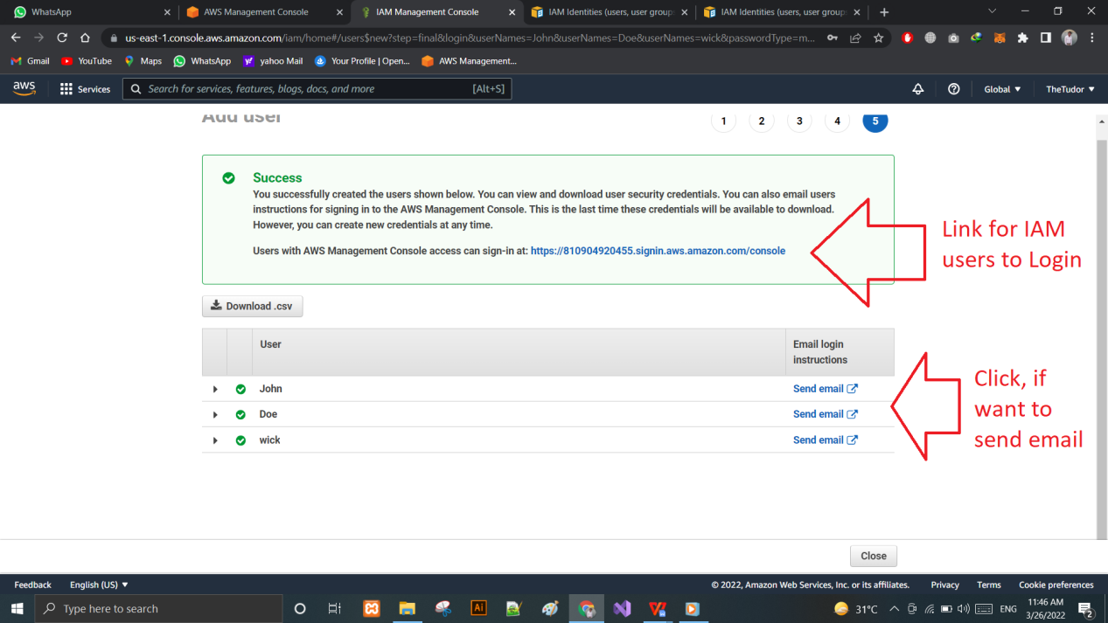

Screenshot: 9: Successful Added

And in the last, just click on the close button. Till now no user has assigned any role.

But all of them can login to the AWS account but they can’t use the AWS services.

Go to the user panel and select 1st user to assign him/her his role.

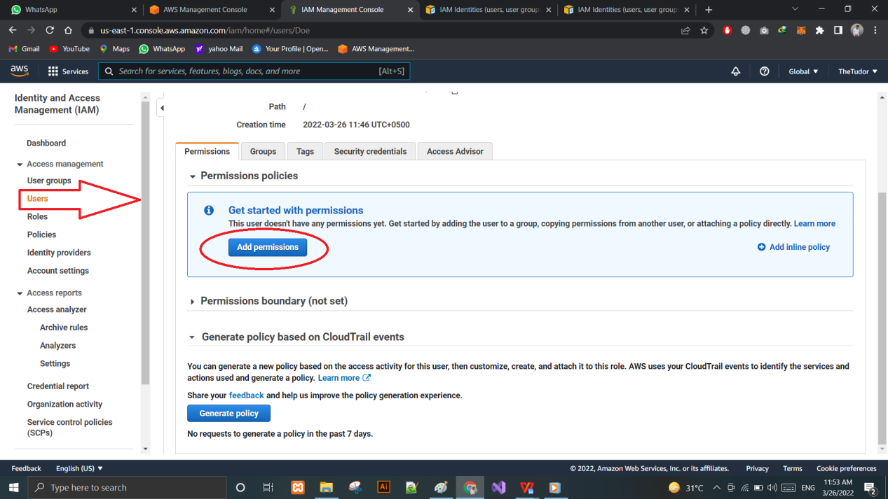

Screenshot: 10: Add Permission 1st user

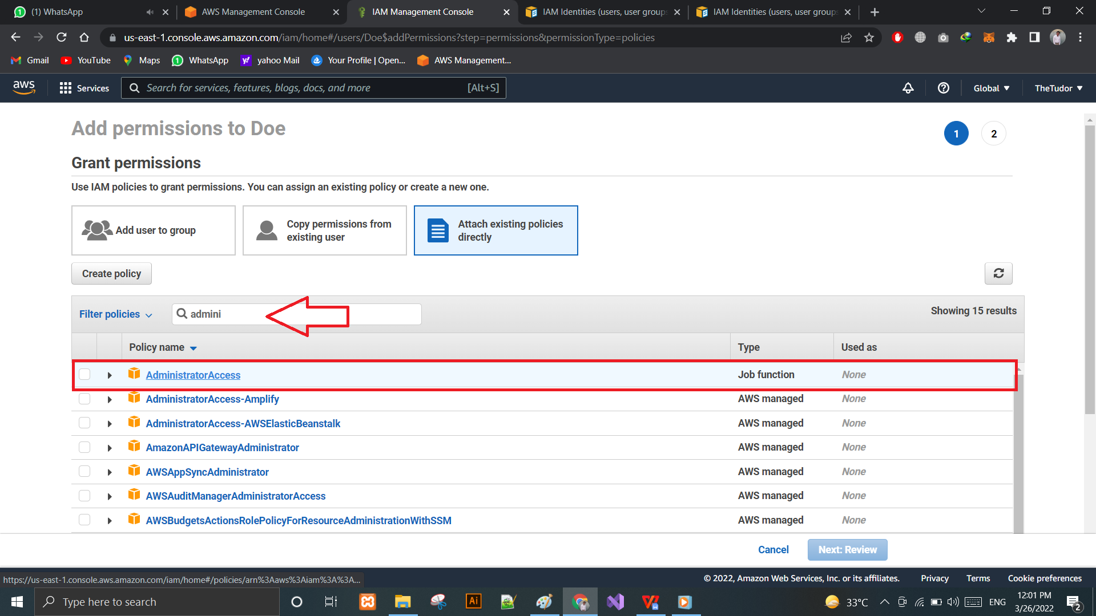

Screenshot: 11: Applied the Administrator Rule

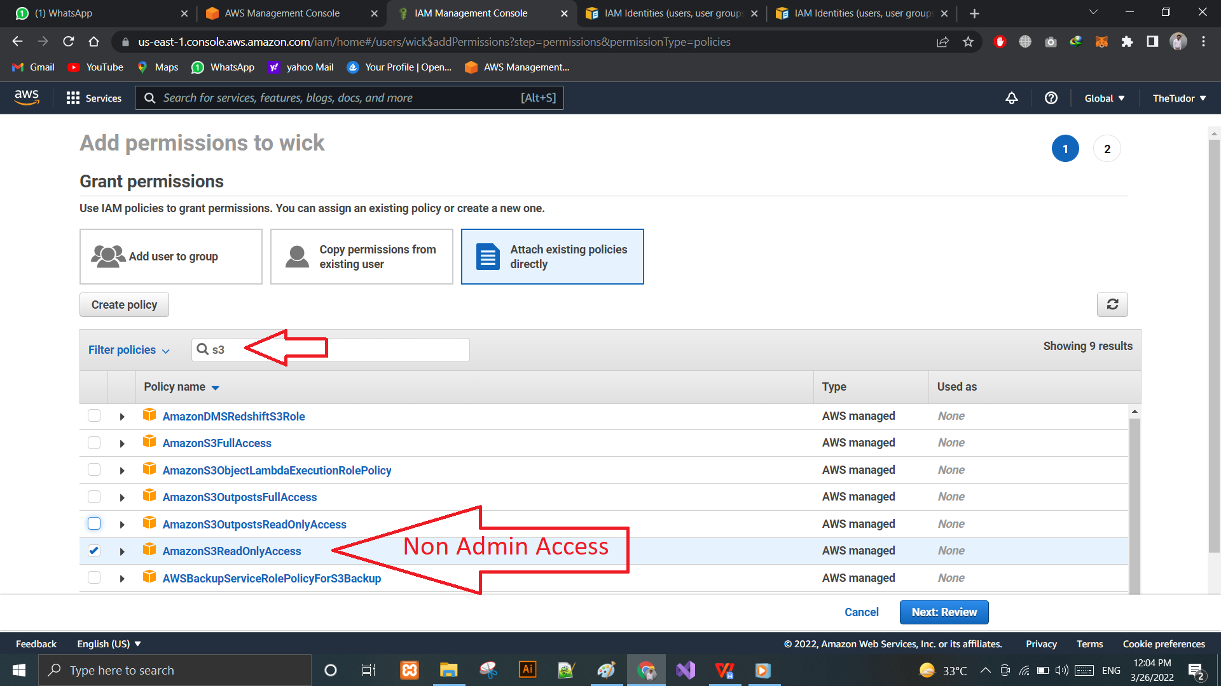

Screenshot: 12: Non-Admin Access

Create a virtual machine (Amazon AMI)

Amazon AMI takes away the complex process of launching instances. Instead, you can use a simple web interface to launch an instance with just a few clicks of the mouse. Not only does it make launching instances simple, but it also is free to use for 60 days so you can try before you buy!

Amazon AMI runs on top of Amazon Elastic Compute Cloud (Amazon EC2) and allows you to launch new instances into a cluster that are linked by private network. This lets you treat your virtual servers as members of a team without worrying about provisioning hardware or having to allocate storage space and network links.

Select “Elastic Beanstalk services from AWS Services”

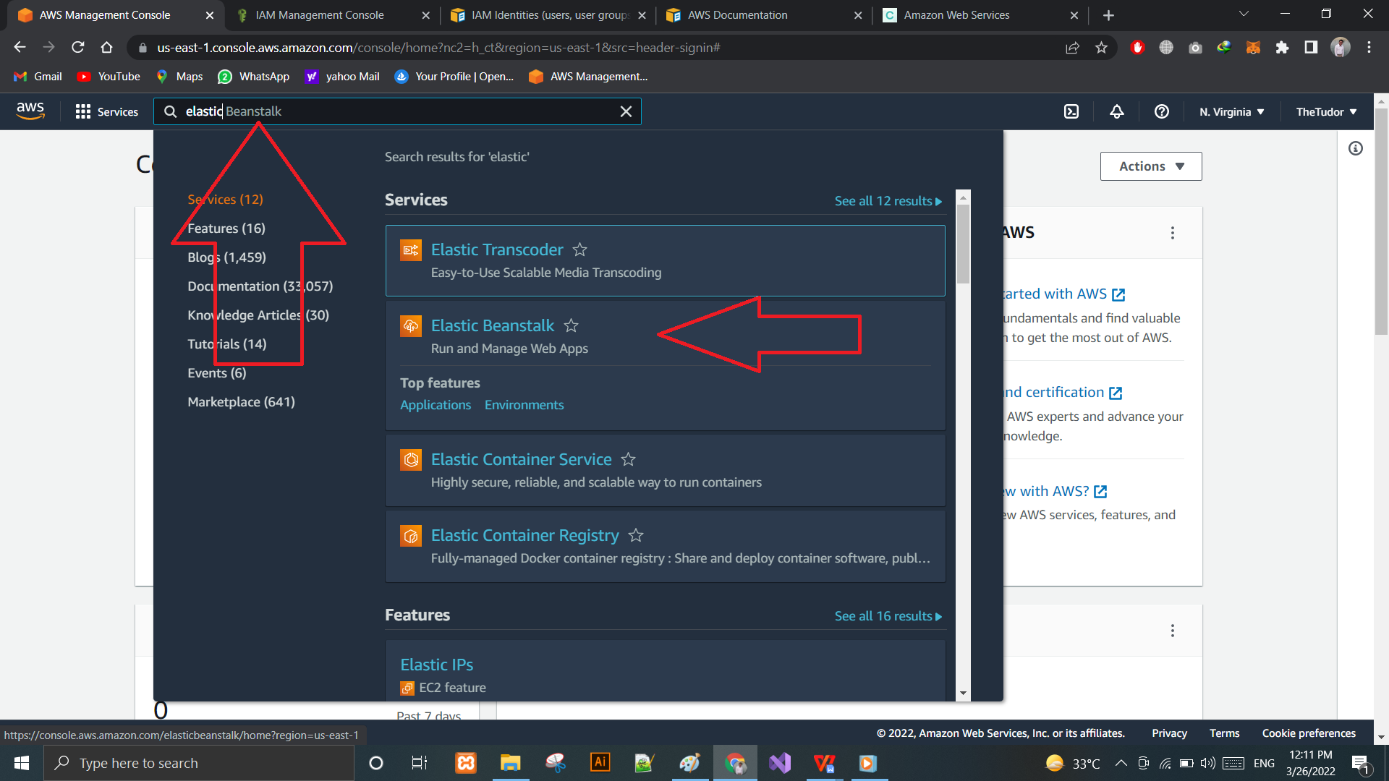

Screenshot: 13: Elastic Beanstalk

Create A New Application in Elastic Beanstalk.

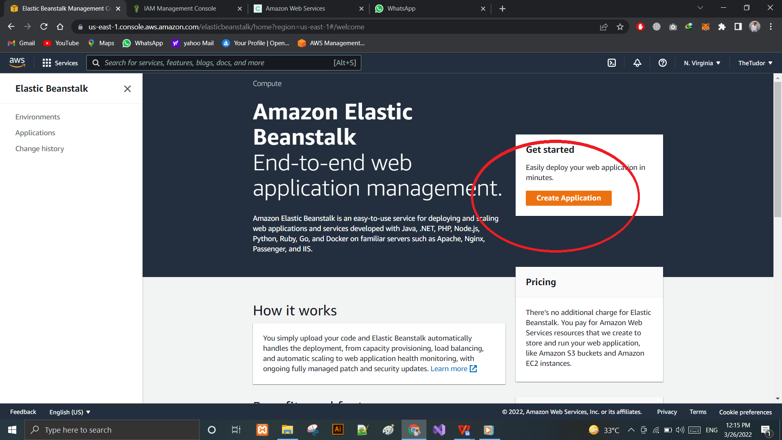

Screenshot: 14:Elastic Beanstalk App

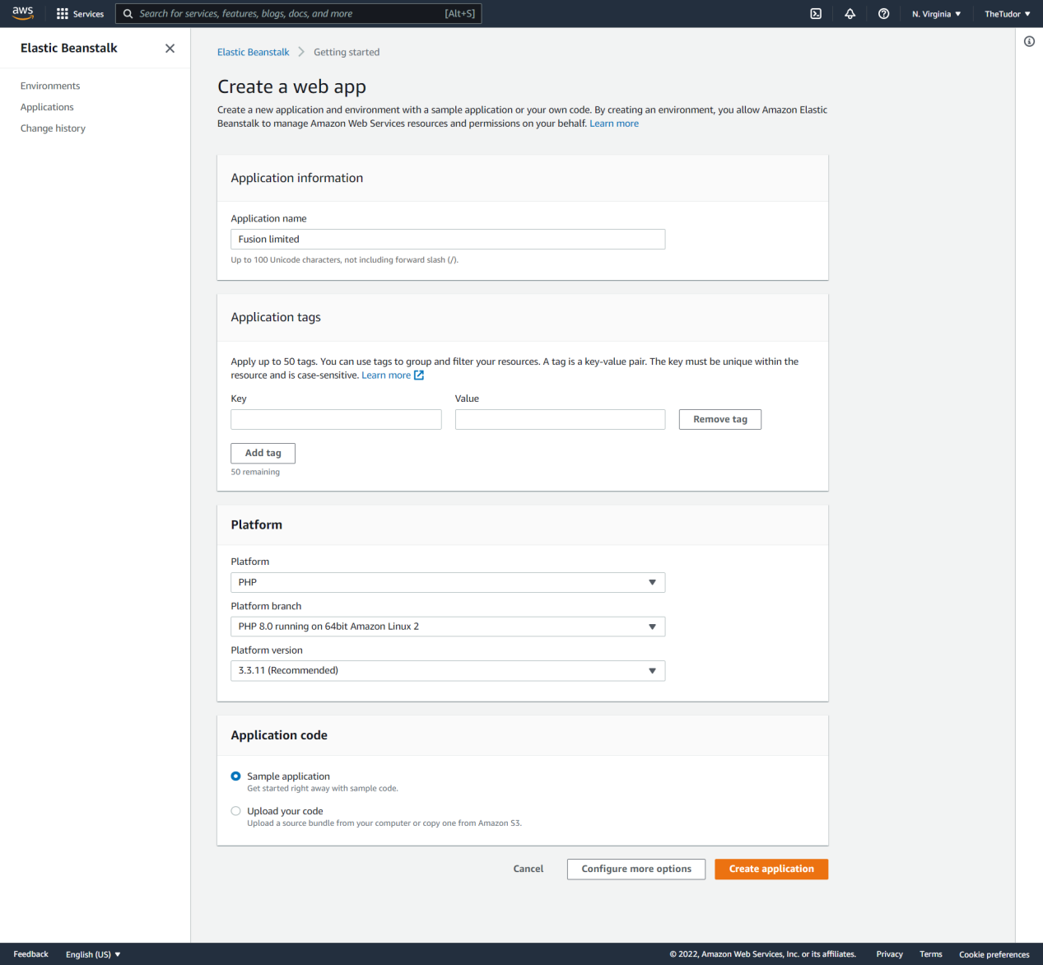

Screenshot: 15: App information

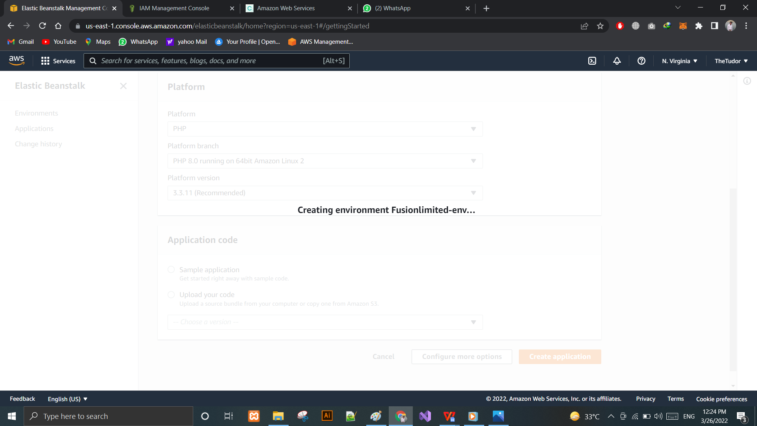Screenshot: 16: Creating Environment

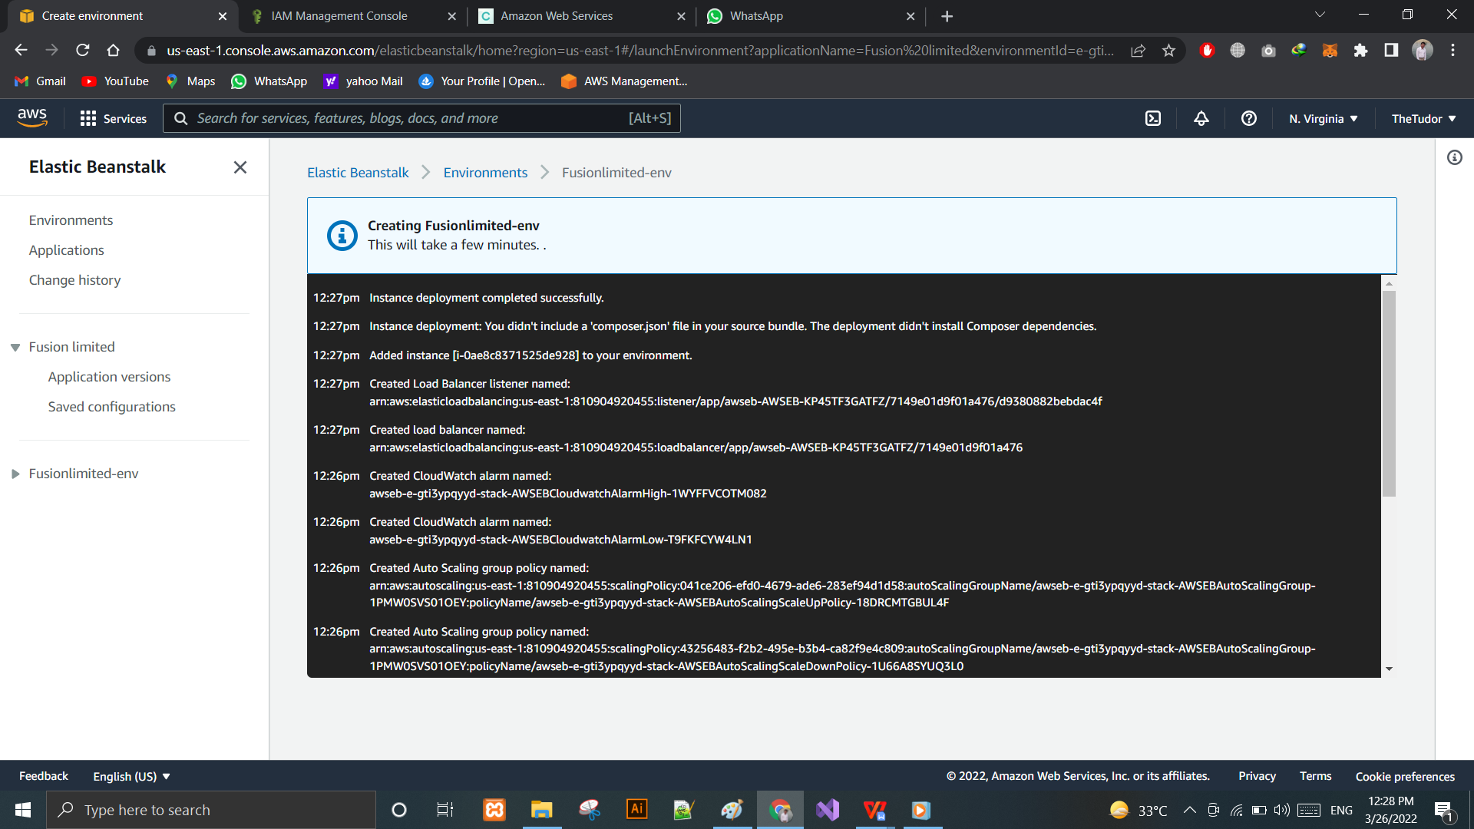

Screenshot: 17: Creating Environment

While creating the environment, AWS Elastic Beanstalk take some time to accomplish the operation.

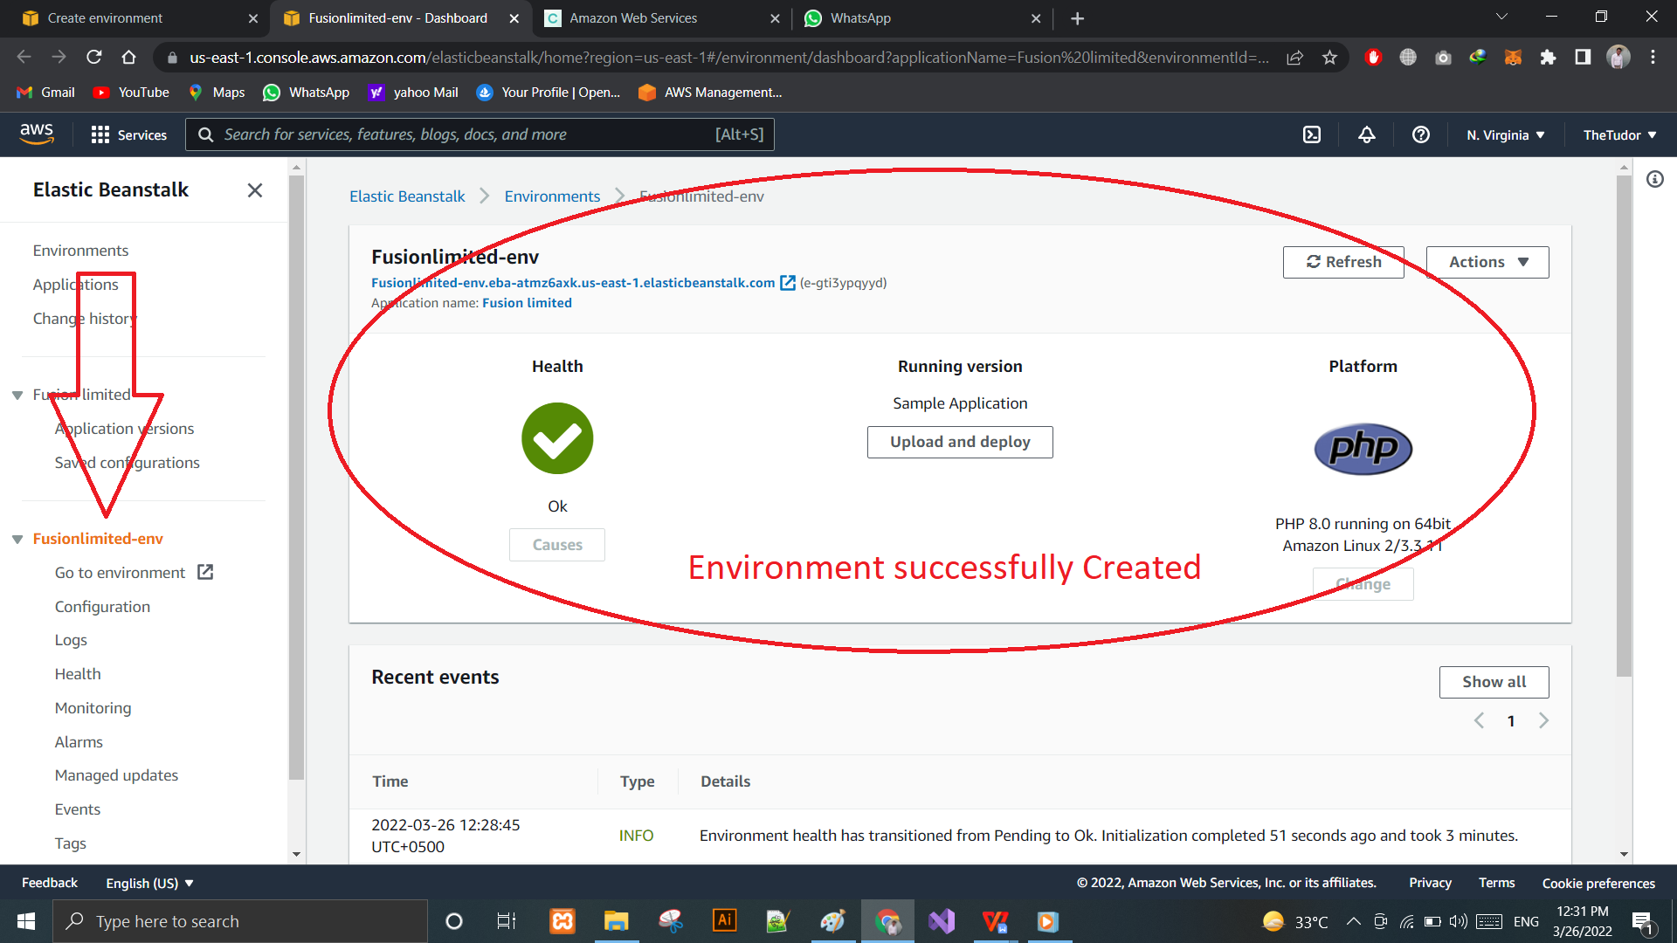

Screenshot: 18: Environment Created

Once the environment is created the, here a sample Application can be seen.

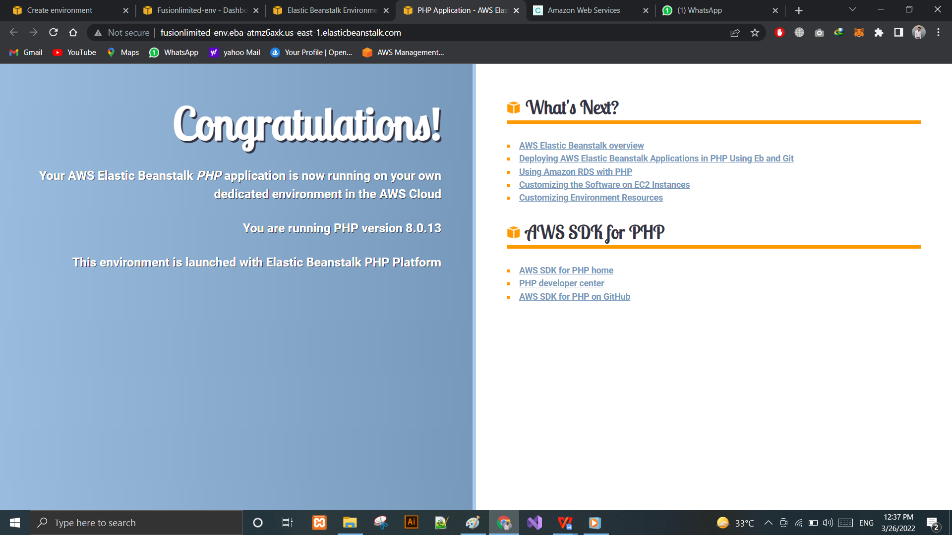

Screenshot: 19: Sample Application

## Security Key Pairs for Current Environment:

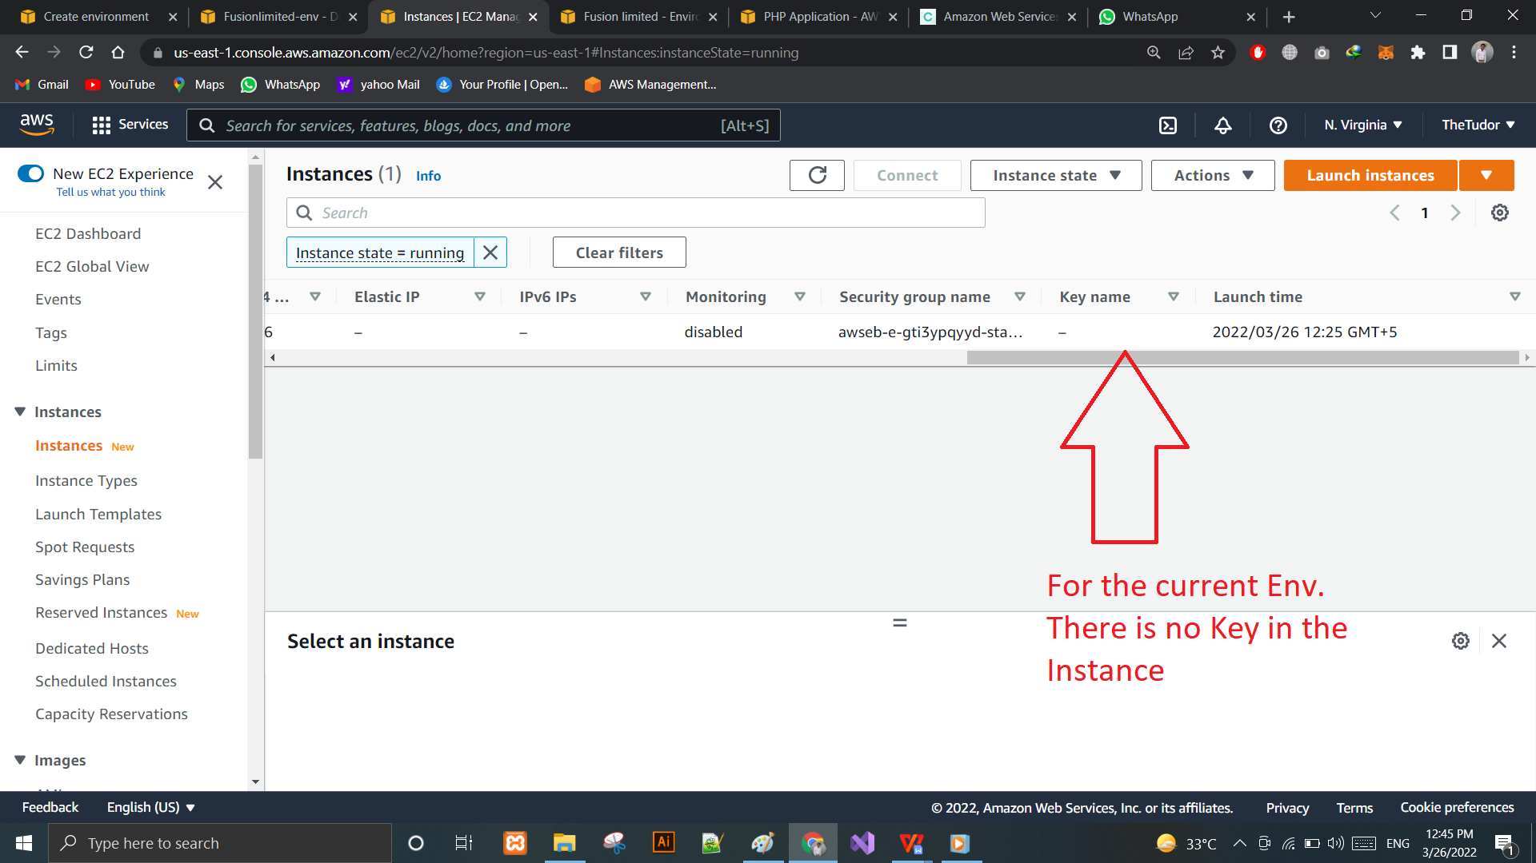

Screenshot: 20: Security Key 1

Select Key pairs option from EC2 View.

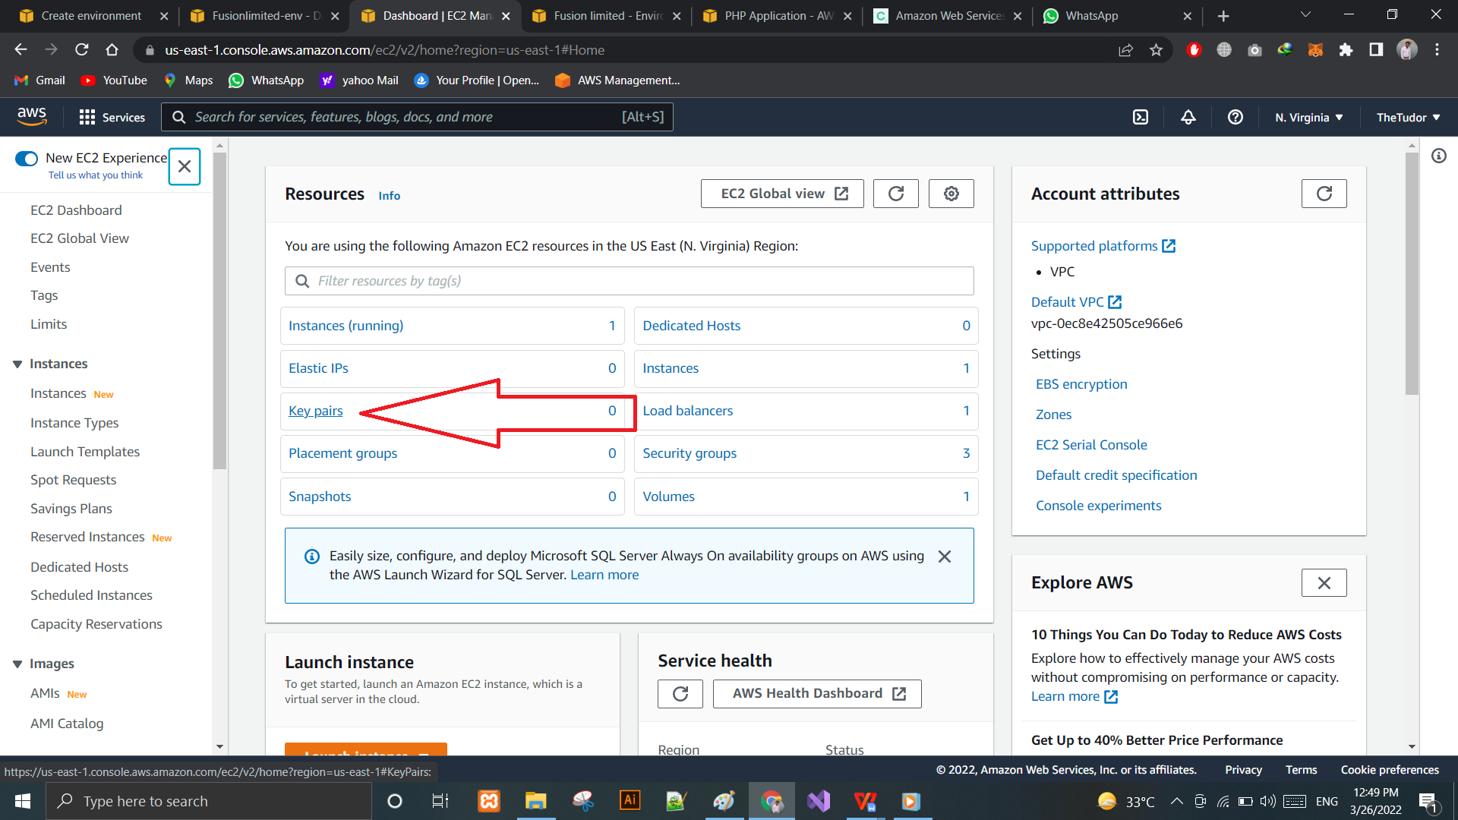

Screenshot: 21: KeyPair 2

Now Create a New KeyPair for the current Fusion limited Environment.

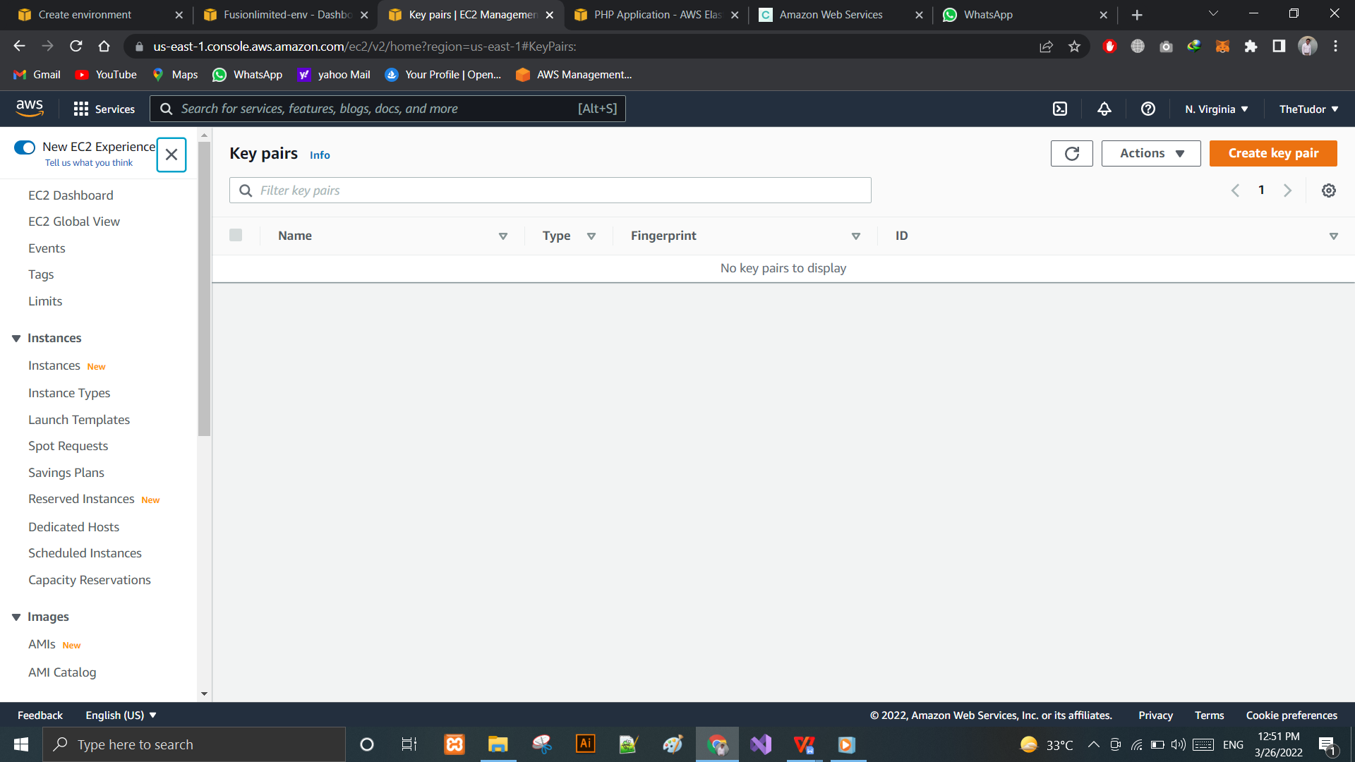

Screenshot: 22: Creating Keypairs

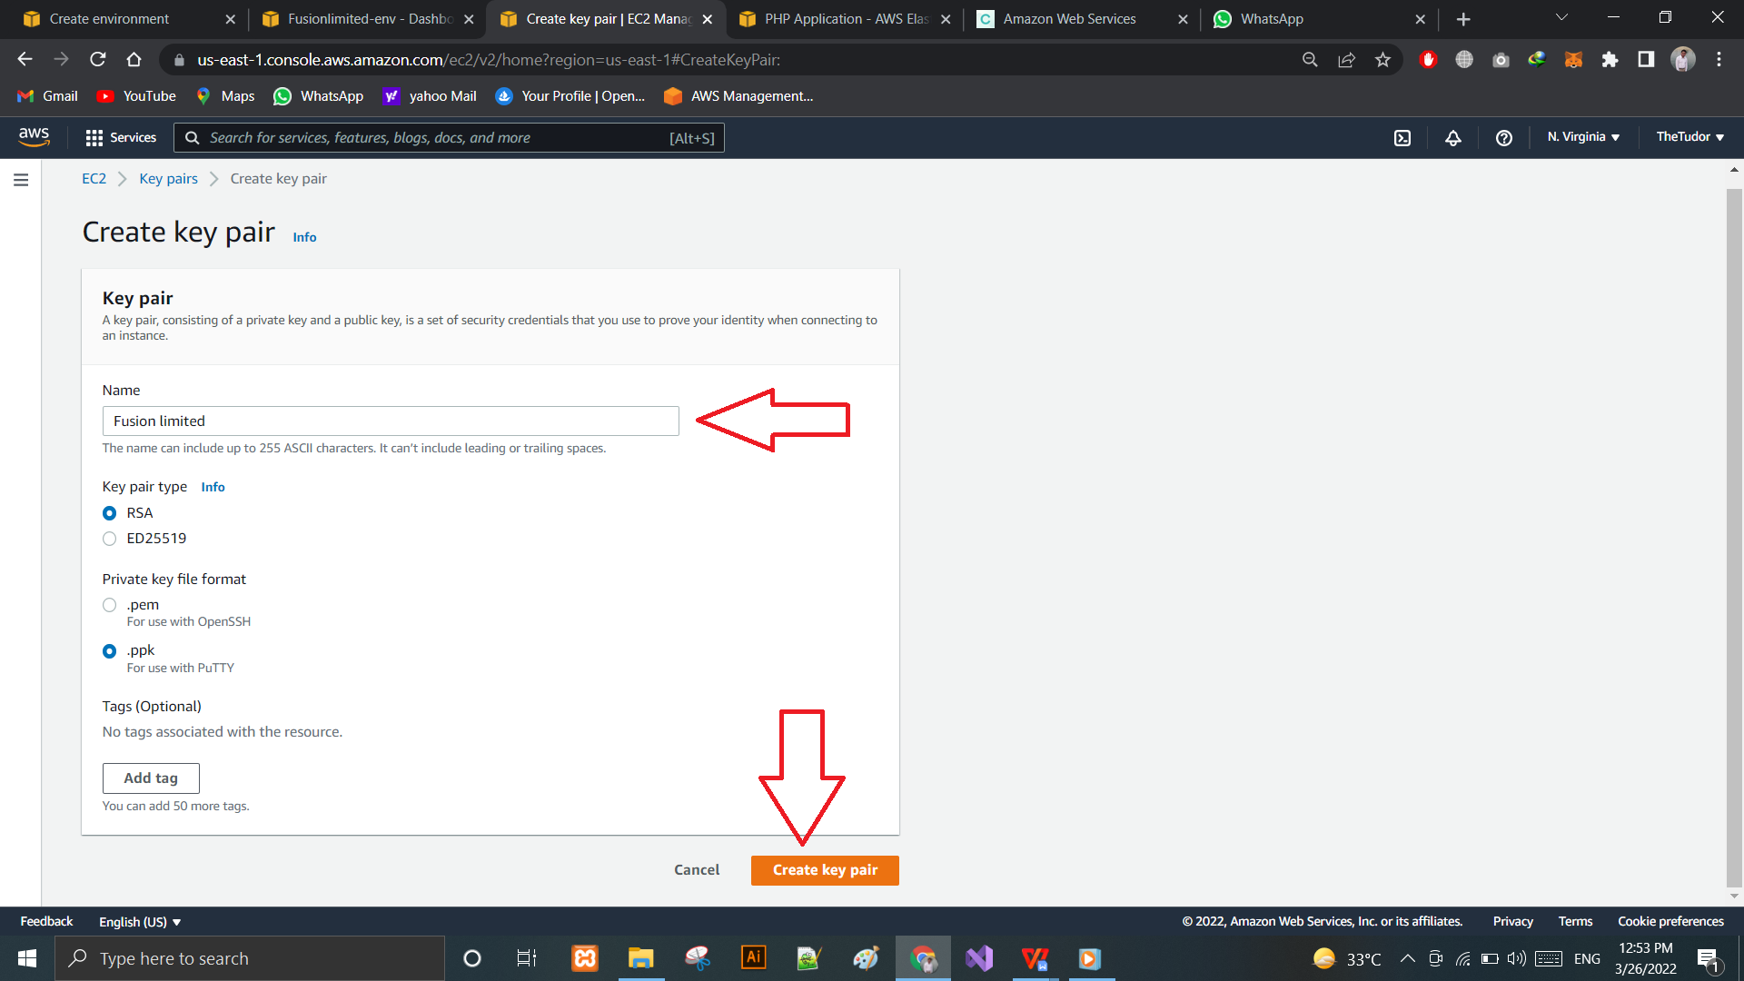

Screenshot: 23: Keypair name

Don’t forget to click on. pem extension for the keypair file.

Once the keypair name is entered and “Create Key Pairs” button is clicked. A file with name “Fusion limitd.pem”

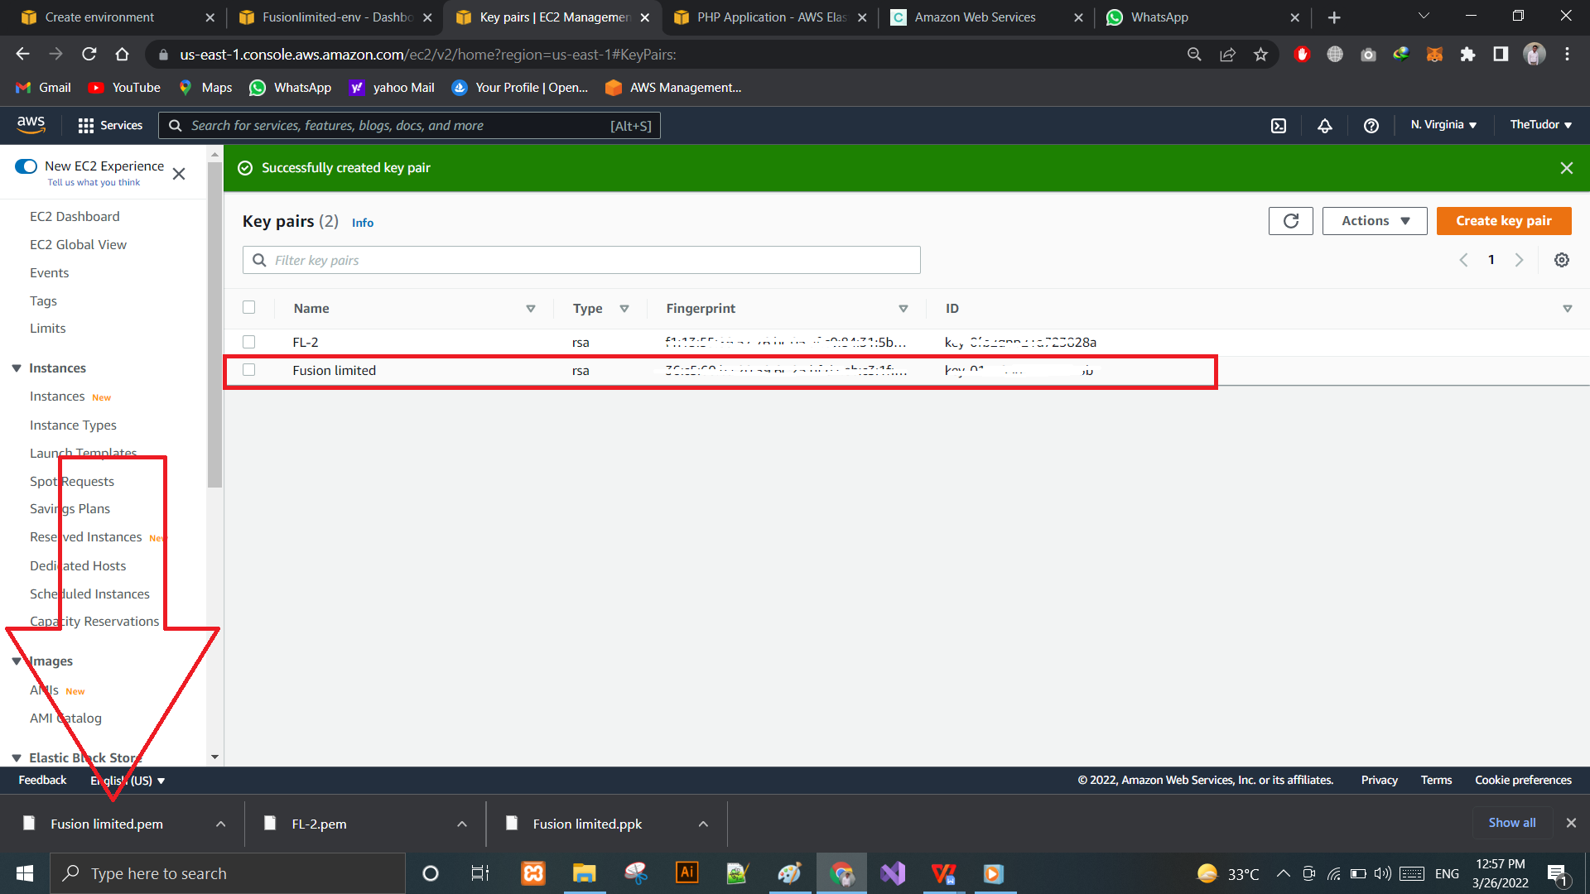

Screenshot: 24: Keypairs success

## Connecting the Keypairs to Current Application Instance

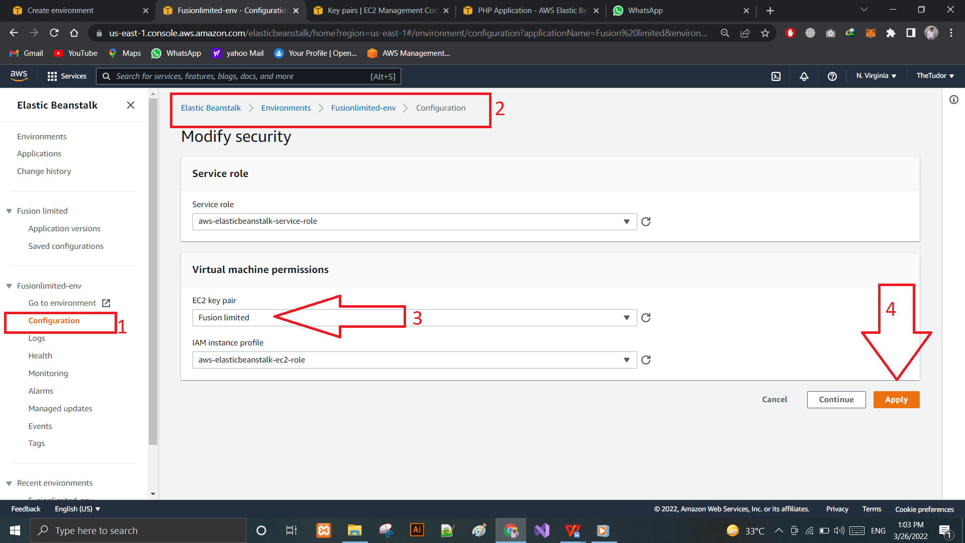

Screenshot: 25: Connect keypairs

Keypairs Connections:

* Go to the Current instance dashboard
* Select configuration from the options
* Select the environment
* Select the keypairs name
* And click connect

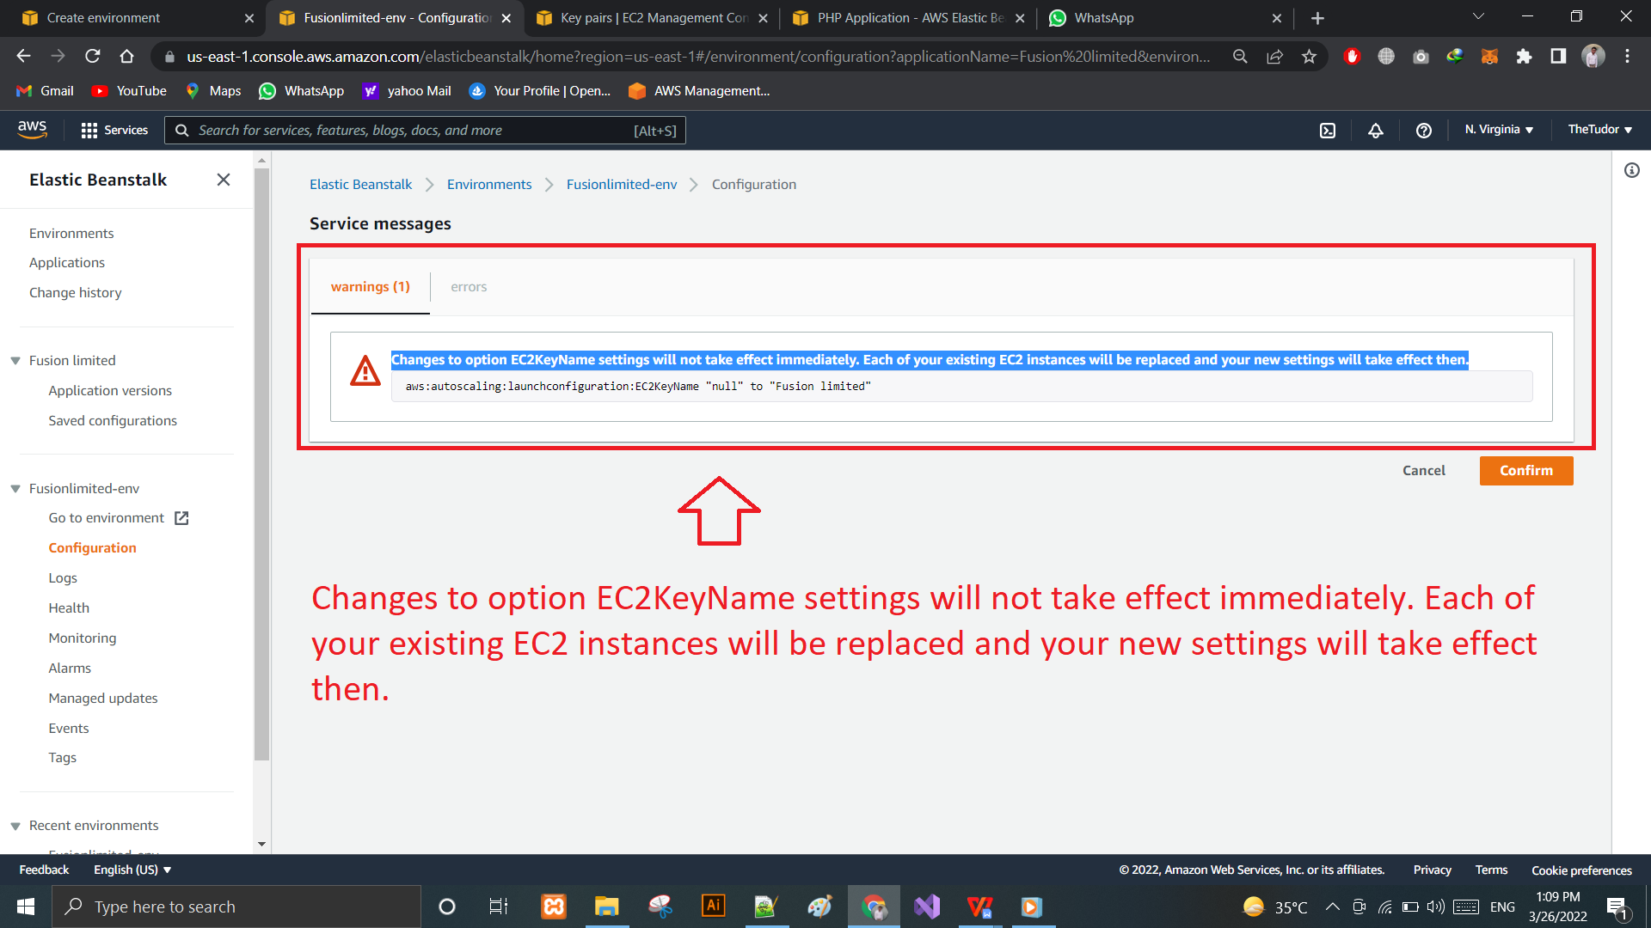

Changes to option EC2KeyName settings will not take effect immediately. Each of your existing EC2 instances will be replaced and your new settings will take effect then.

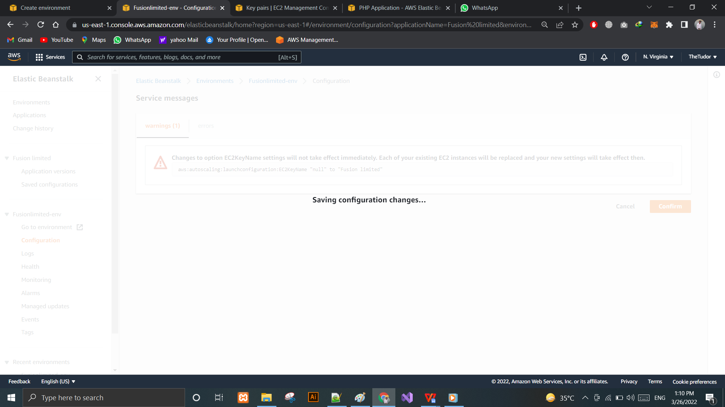

The Key has been connected successfully.

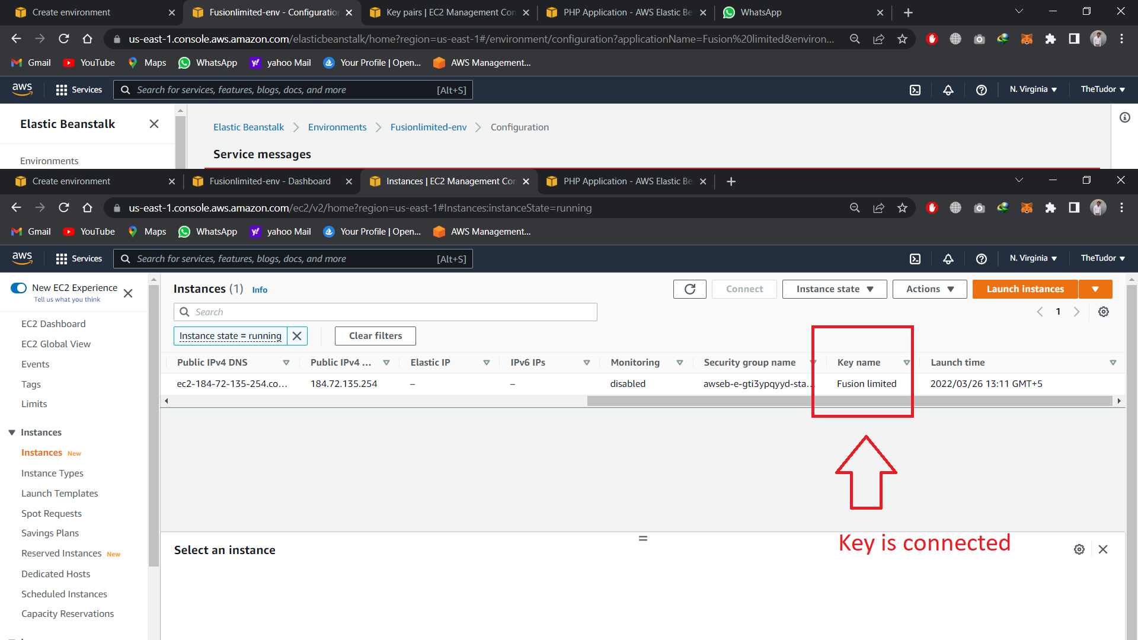

Screenshot: 26: Key Connected Success

Now opening the cmd and setting up the IP address and connecting the Keypairs with the given IP.

C:\Users\DELL\Downloads> ssh ec2-user@184.72.135.254 -i Fusionlimited.pem

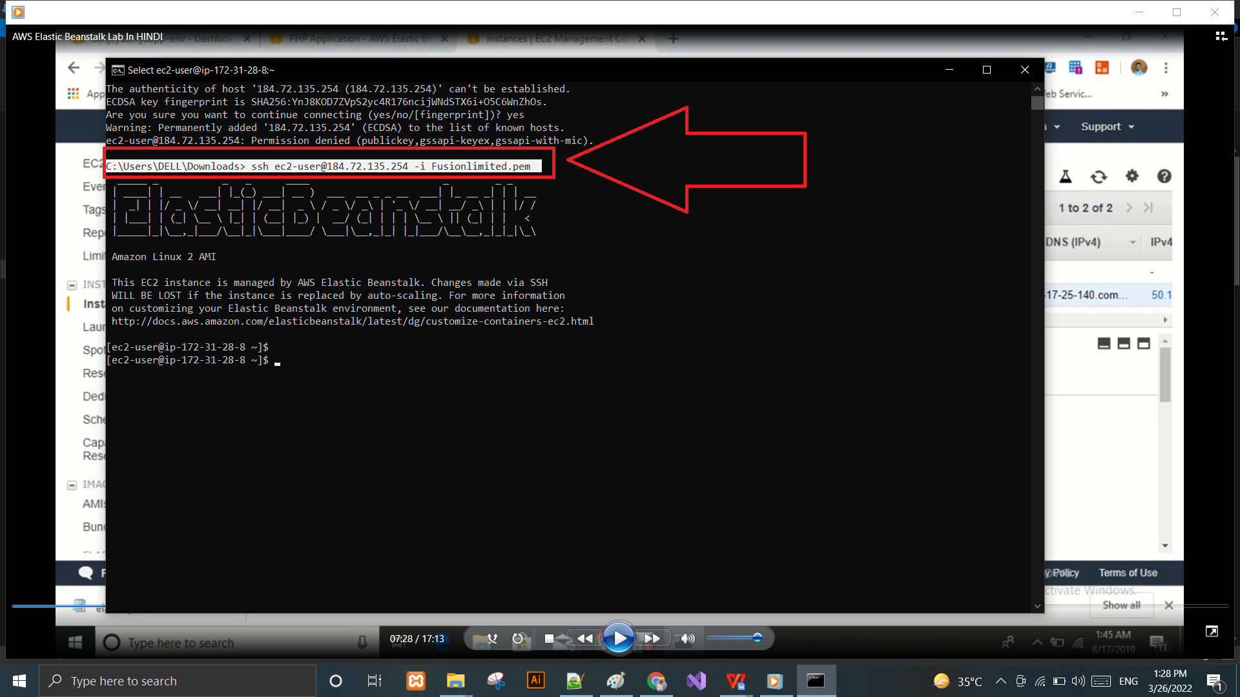

It is due to changes in the configuration of the ec2 instance it has to be reset.

[ec2-user@ip-172-31-28-8 ~]$

[ec2-user@ip-172-31-28-8 ~]$ cd /var/www/html/

[ec2-user@ip-172-31-28-8 html]$ ll

After writing the above command it will show up like this.

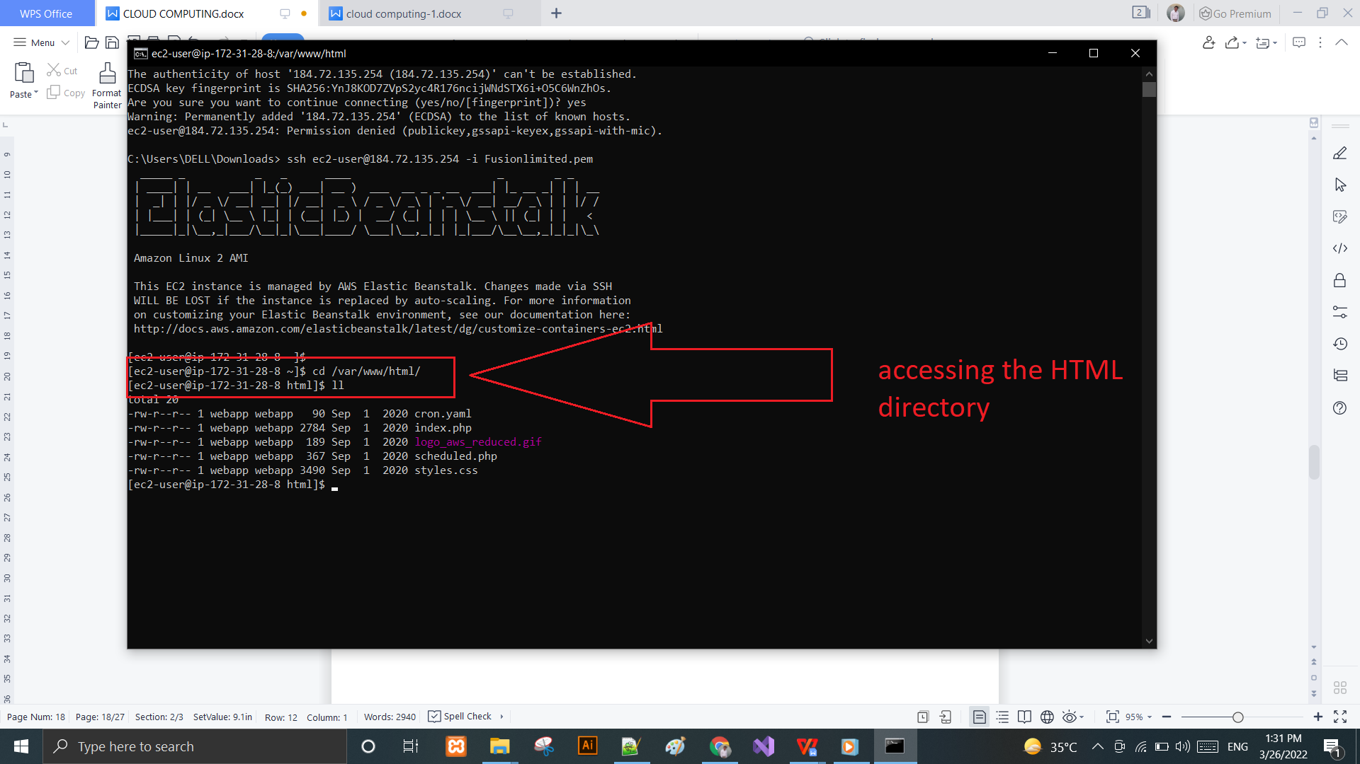

Now it’s all set to go.

# Task 2: Amazon Relational Database (RDS)

Thanks to amazon relational database service (rds) subscription options, customers do now no longer have to shop for any server or set up any database software program in it. Amazon relational database service (rds) lets in customers to pay attention on growing programs and making sure that they`ve the specified overall performance and security. The amazon relational database service (rds) became released in october 2009 and is designed to host relational database times withinside the cloud to assist programs` operations and offer records for analytics, reporting, and commercial enterprise dashboards. The relational databases supported through amazon relational database service (rds) consist of mysql, postgresql, mariadb, oracle, microsoft square server, and amazon aurora. This is a totally controlled relational database engine this is like minded with mysql and postgresql a database example is completely unique surroundings created withinside the aws cloud. Amazon considers database times to be the fundamental constructing block of the amazon relational database service (rds).

## Creating RDS in AWS

Select RDS from AWS database services:

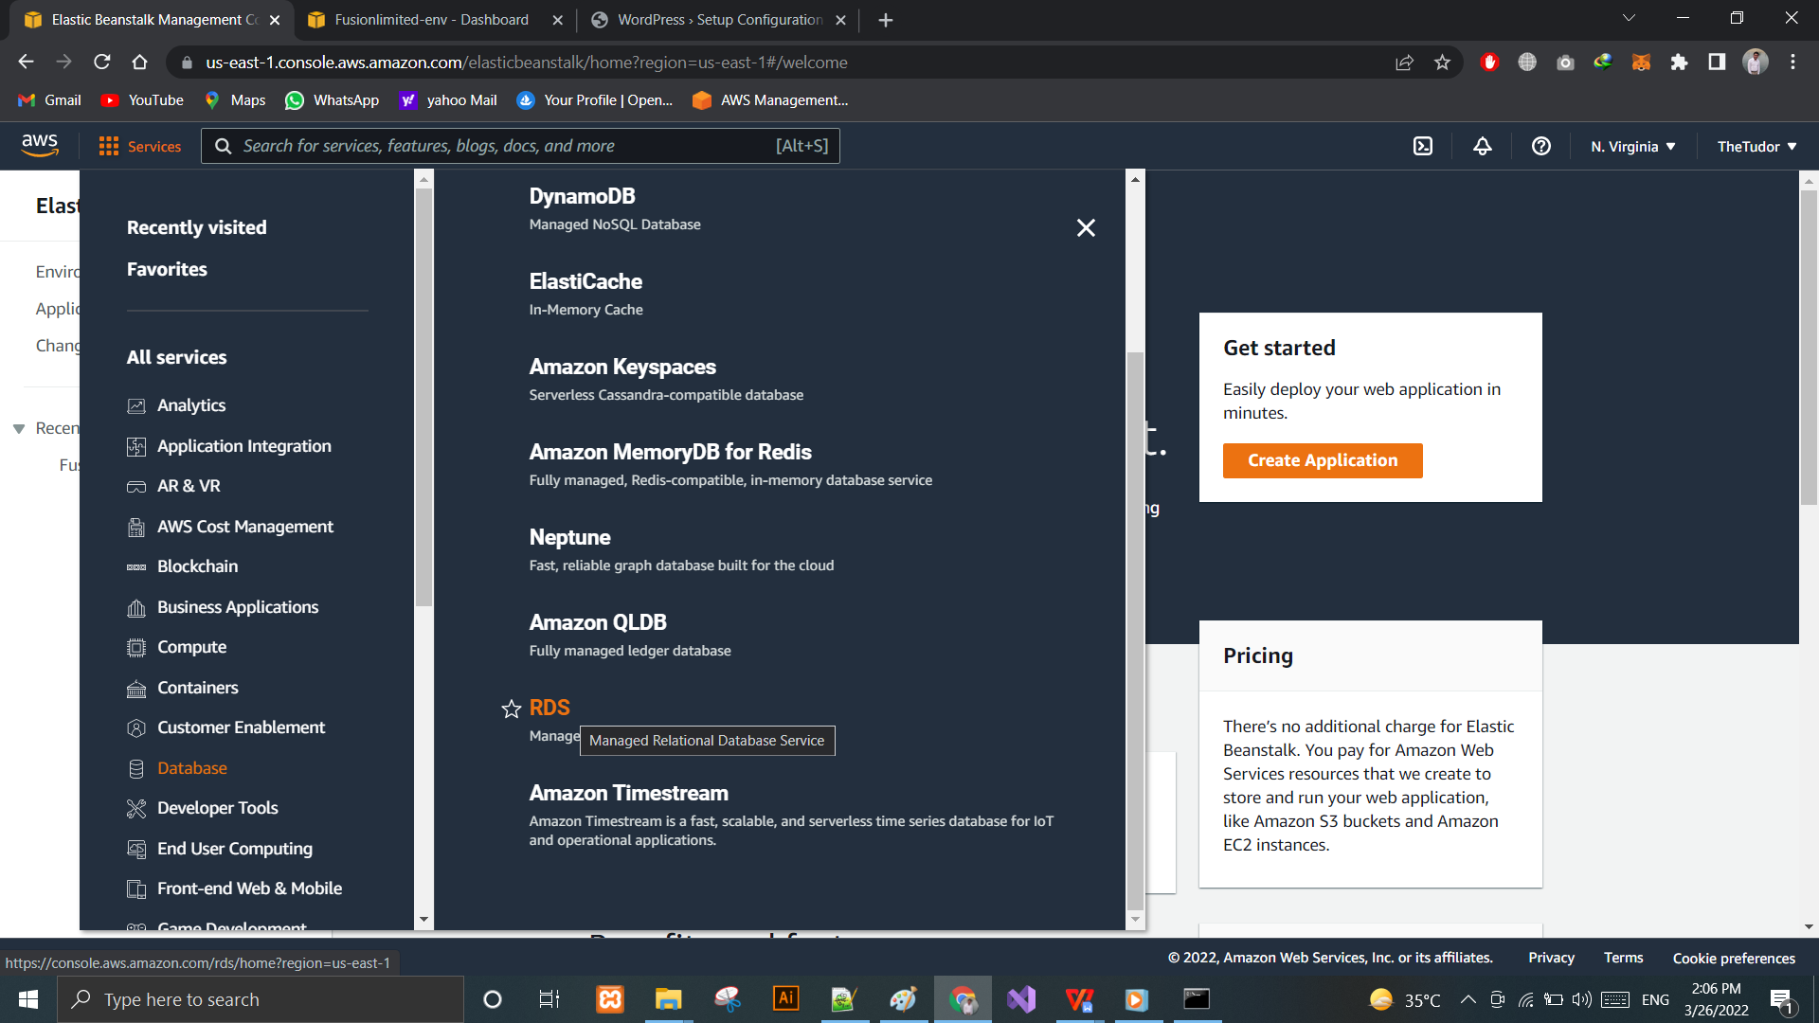

Screenshot: 27: RDS 1

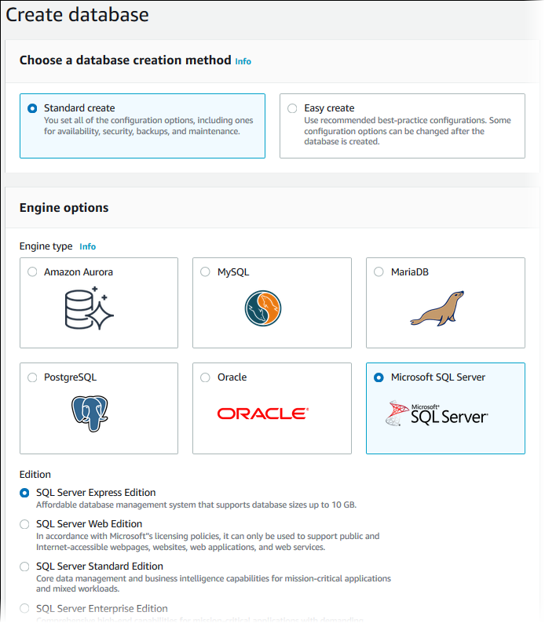

# Task 3:

## Amazon SageMaker

One of the most interesting announcements from AWS re:Invent 2017 was Amazon SageMaker, a fully-managed machine learning platform for developers and data scientists to build, train, and deploy machine learning models without having to worry about IT infrastructure. Developers has always been offered the choice of two main types of cloud computing models to work on: the public Cloud or the private Cloud. The public Cloud possibly has more flexibility, but at a price: you don't know if your data is kept safe or stored somewhere where it can be accessed by third parties. The other one, the private Cloud, ensures that all information is highly-secured and will never be shared with third parties, but it gives developers no flexibility — they must work on predefined servers with pre-installed software.

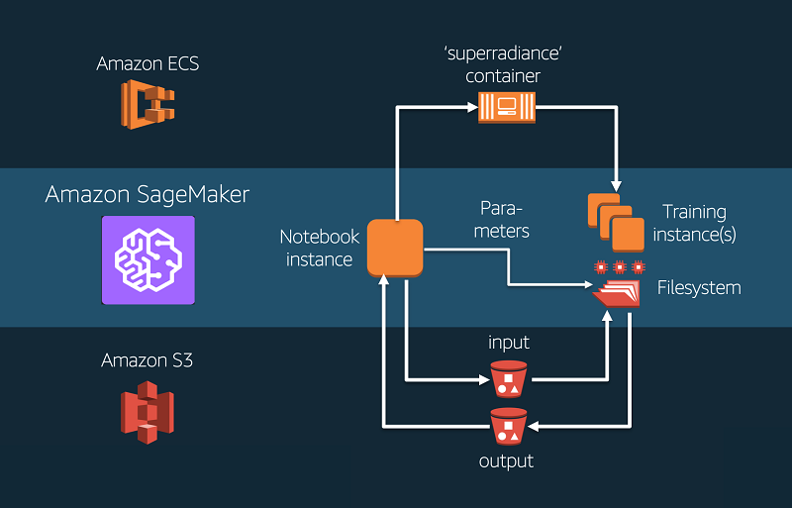

Today, many companies are rethinking the way they develop and deploy their machine learning models. They no longer use a single platform to build, train and run their ML models. Nor do they rely on batch processing or traditional environments that take significant time to set up and configure.

## Amazon Redshift

Amazon Redshift is a fully managed, cloud-based data warehouse solution that makes it simple and cost-effective to efficiently analyze all your data using your existing business intelligence tools and scale without upfront investment. Amazon Redshift is a fast, fully managed, petabyte-scale data warehouse service in the cloud. You can build relational database tables from your Amazon S3 files using your familiar SQL query language, load your tables with data from S3 or directly from AWS Glue crawls, and manipulate data in your tables using standard SQL.

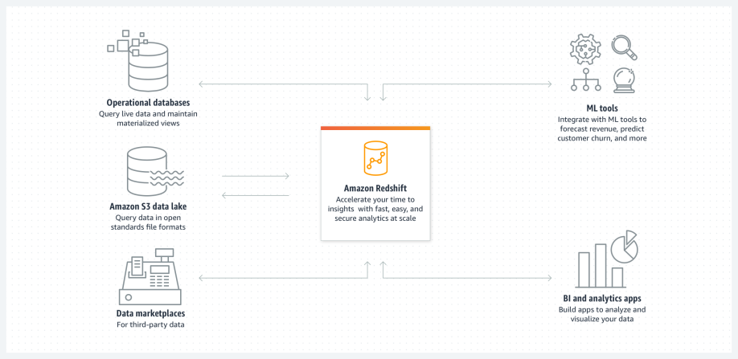

## Amazon CloudSearch

Amazon CloudSearch is a web service that makes it easy to set up, operate, and scale a search solution in the cloud. It supports fast and scalable indexing of structured and unstructured data; text search, faceted search, and other advanced search functionality; and real-time index updates with partial queries, field data, and document payloads. It also enables developers to integrate search into their applications with simple REST APIs or SDKs for Java, .NET, PHP, Python, and Ruby.

## Benefits

With Amazon CloudSearch, you could speedy upload wealthy seek abilties in your internet site or application. You don't want to end up seeking a seek professional or fear approximately hardware provisioning, setup, and maintenance. With some clicks withinside the AWS Management Console, you could create a seek area and add the information which you need to make it searchable, and Amazon CloudSearch will routinely provision the specified assets and installation a surprisingly tuned seek index.  
You can effortlessly extrade your seek parameters, great music seek relevance, and observe new settings at any time. As your extent of information and site visitors fluctuates, Amazon CloudSearch seamlessly scales to satisfy your needs.  
Simple  
You can configure and manipulate an Amazon CloudSearch area thru the AWS Management Console, AWS CLI, and AWS SDKs. Simply factor to a pattern of your information and Amazon CloudSearch will routinely suggest the way to configure your area's indexing alternatives. You can effortlessly upload or delete index fields and customise seek alternatives which includes faceting and highlighting. Configuration adjustments do now no longer require you to re-add your information.  
Scalable  
Amazon CloudSearch gives effective autoscaling for all seek domains. As your information or question extent adjustments, Amazon CloudSearch can scale your seek area's assets up or down as needed. You can manage scaling in case you recognize which you want extra potential for bulk uploads or are looking ahead to a surge in seek site visitors.  
Reliable  
Amazon CloudSearch gives automated tracking and restoration on your seek domains. When Multi-AZ is enabled, Amazon CloudSearch provisions and continues assets for a seek area in Availability Zones to ensure excessive availability. Updates are routinely carried out to the quest times in each Availability Zones. Search site visitors is sent throughout each availability zone and the times in both sectors are able to deal with the whole load withinside the occasion of a failure.  
High Performance  
Amazon CloudSearch guarantees low latency and excessive throughput performance, even at a huge scale thru automated sharding and horizontal and vertical autoscaling.  
Fully Managed  
Amazon CloudSearch is a totally controlled custom seek provider. Hardware and software program provisioning, setup and configuration, software program patching, information partitioning, node tracking, scaling, and information sturdiness are treated for you.  
Rich Search Features  
Amazon cloudsearch helps effective seek functions which includes: Free text, boolean, and faceted seek autocomplete suggestions customizable relevance rating and question-time rank expressions field weighting geospatial seek highlighting support for 34 languages  
  
Cost-Effective Amazon CloudSearch is designed to be value-effective. You pay low hourly rates, and best for the assets you use. Amazon CloudSearch gives a low general value of possession on your seek packages in comparison to working a seek surroundings in your own. For designated pricing information, see Pricing.

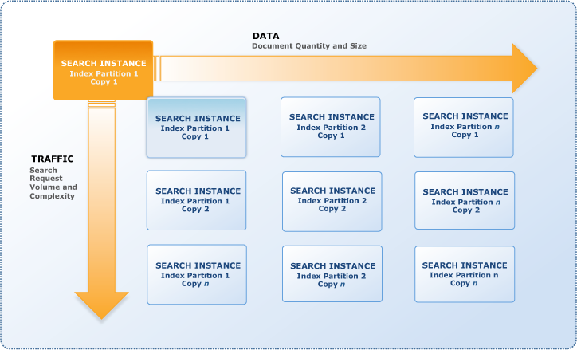

## Amazon guardDuty

Amazon GuardDuty is a risk detection provider that constantly video display units for malicious interest and anomalous conduct to defend your AWS accounts, workloads, and information saved in Amazon Simple Storage Service (Amazon S3). GuardDuty makes use of numerous strategies to pick out signs of compromise, together with gadget learning (ML), anomaly detection, and included risk intelligence to pick out and prioritize capacity threats. GuardDuty is able to read tens of billions of occasions throughout more than one AWS information sources, together with AWS CloudTrail occasion logs, Amazon Virtual Private Cloud (VPC) go with the drift Logs, and DNS question logs.

## Threat severity degrees for green prioritization

Amazon GuardDuty affords 3 severity degrees (Low, Medium, and High) to assist clients prioritize their reaction to capability threats. A “Low” severity degree shows suspicious or malicious interest that became blocked earlier than it compromised your aid. A “Medium” severity degree shows suspicious interest. For example, a big quantity of visitors back to a far-off host hiding at the back of the Tor community, or interest that deviates from usually determined behavior. A “High” severity degree shows that the aid in question (e.g., an Amazon EC2 example or a hard and fast of IAM consumer credentials) is compromised and is actively getting used for unauthorized purposes.

## Threat reaction and remediation automation

Amazon GuardDuty gives HTTPS APIs, command-line interface (CLI) tools, and Amazon CloudWatch Events to help automatic safety responses to safety findings. For example, you could automate the reaction workflow via way of means of the use of CloudWatch Events as an occasion supply to cause an AWS Lambda function.

## Highly to be had danger detection

Amazon GuardDuty is designed to robotically manipulate aid usage primarily based totally on the general interest degrees inside your AWS debts, workloads, and records saved in Amazon S3. GuardDuty provides detection capability most effective while necessary, and decreases usage while capability is now not needed. You now have a cost-powerful structure that continues the safety processing strength you want whilst minimizing expenses. You most effective pay for the detection capability you operate, while you operate it. GuardDuty offers you safety at scale, irrespective of your size.

One-click on deployment without an extra software program or infrastructure to set up and manipulate

With one click on withinside the AWS Management Console or a unmarried API call, you could permit Amazon GuardDuty on a unmarried account. With some extra clicks withinside the console, you could permit GuardDuty throughout a couple of debts. Amazon GuardDuty helps a couple of debts thru AWS Organizations integration in addition to natively inside GuardDuty. Once enabled, GuardDuty without delay begins offevolved studying non-stop streams of account and community interest in close to actual time and at scale. There aren't anyt any extra safety software program, sensors, or community home equipment to set up or manipulate. Threat intelligence is pre-incorporated into the provider and are constantly up to date and maintained.

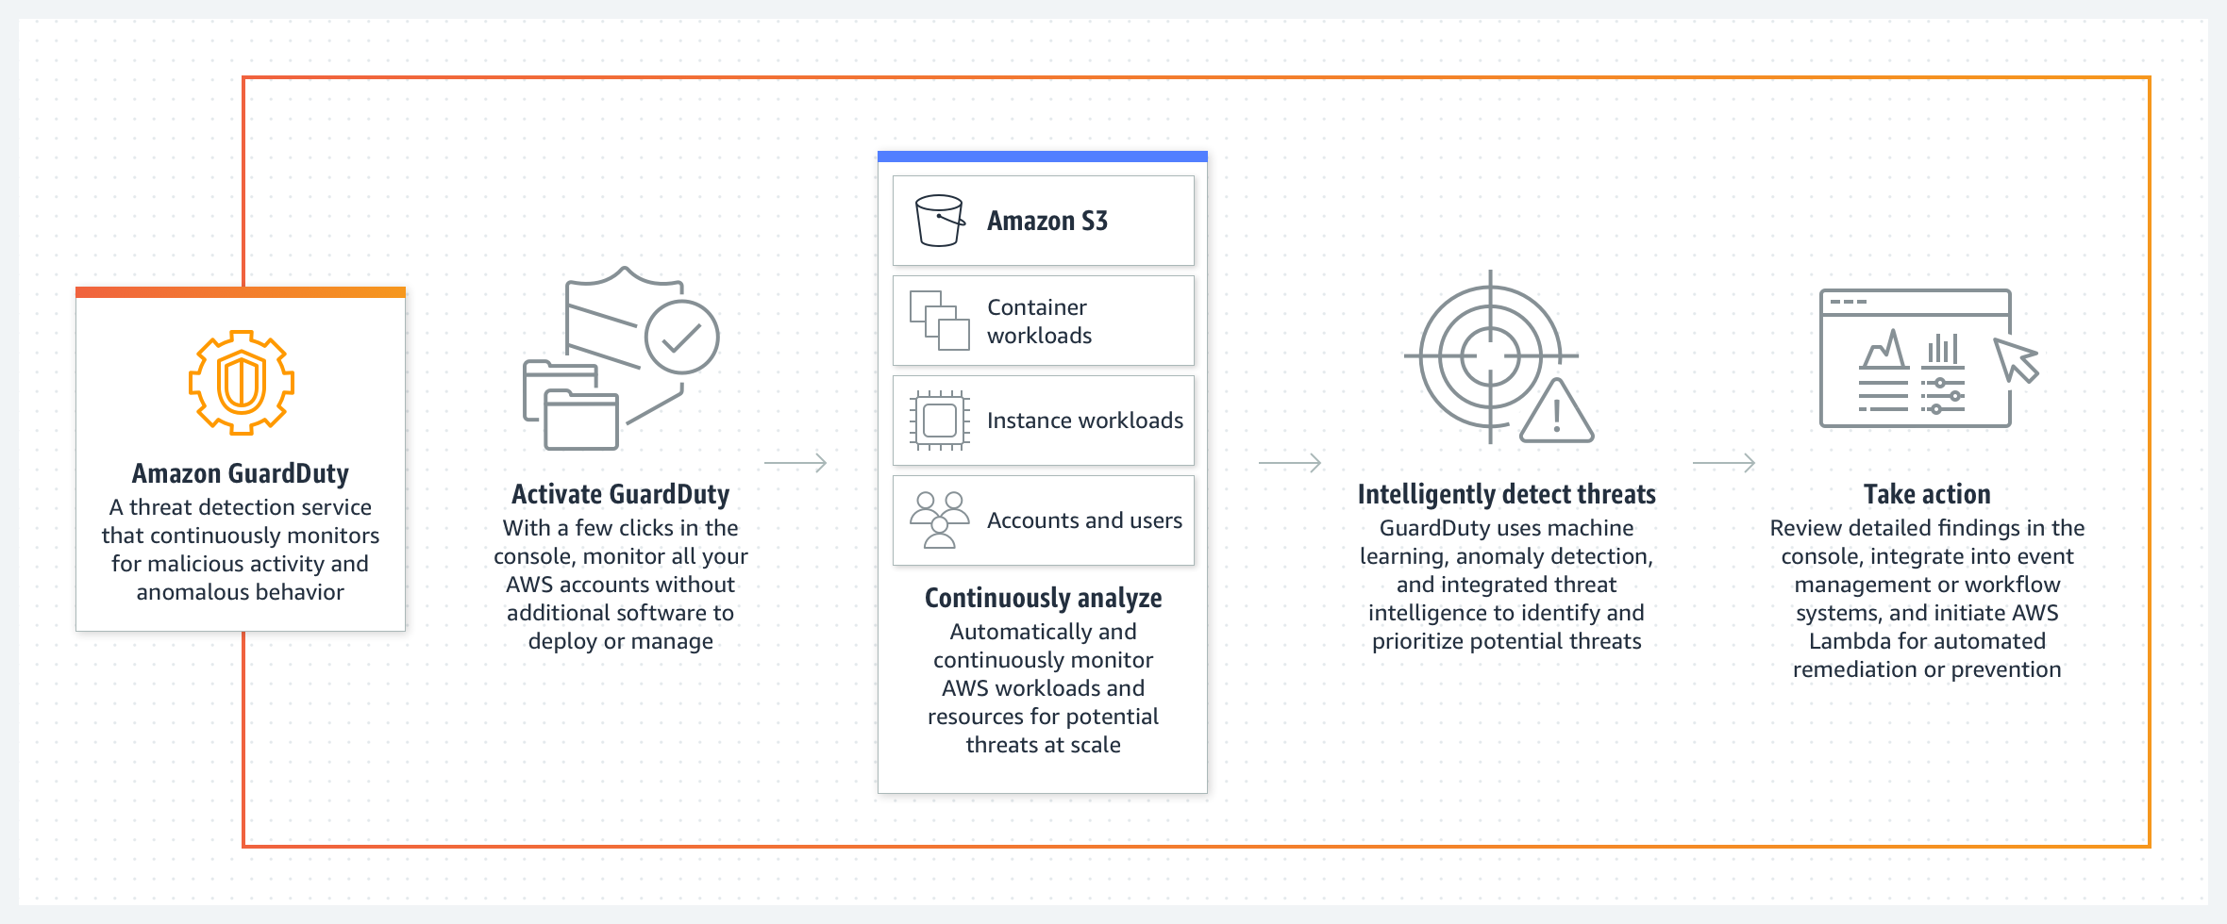

## Deploying the New Application version

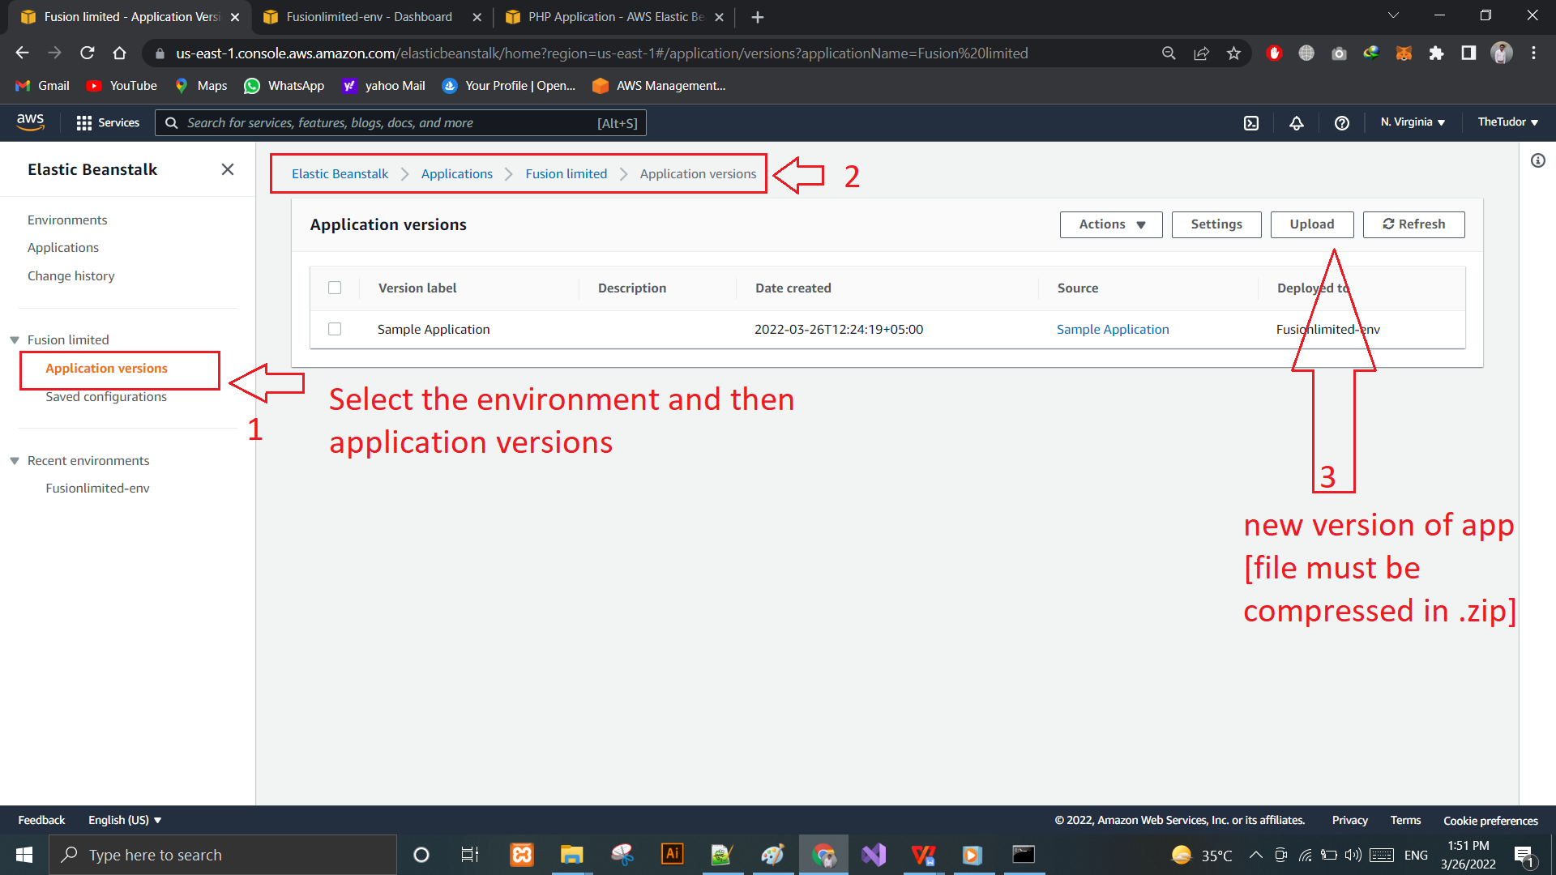

Screenshot: 28: New App version

Uploading new version:

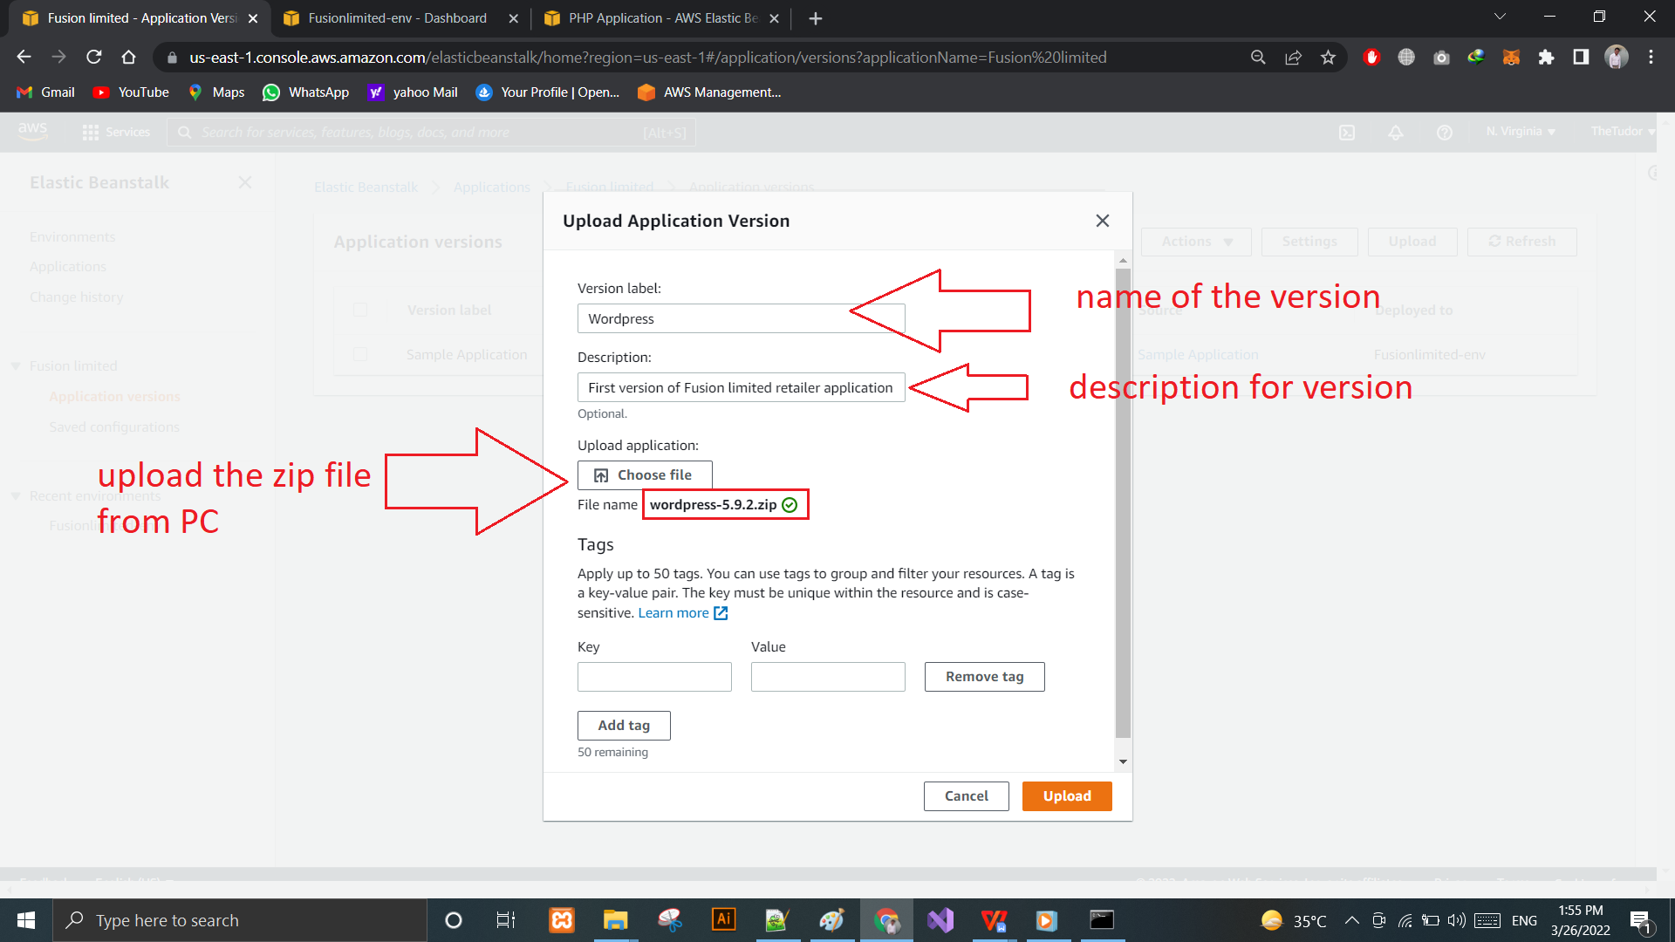

Screenshot: 29: Upload New Version

Successful Upload:

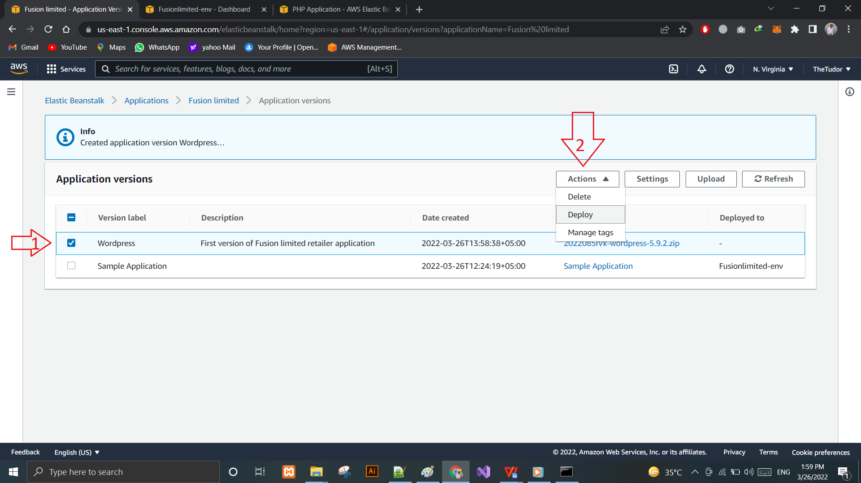

Screenshot: 30: New Version Deployed

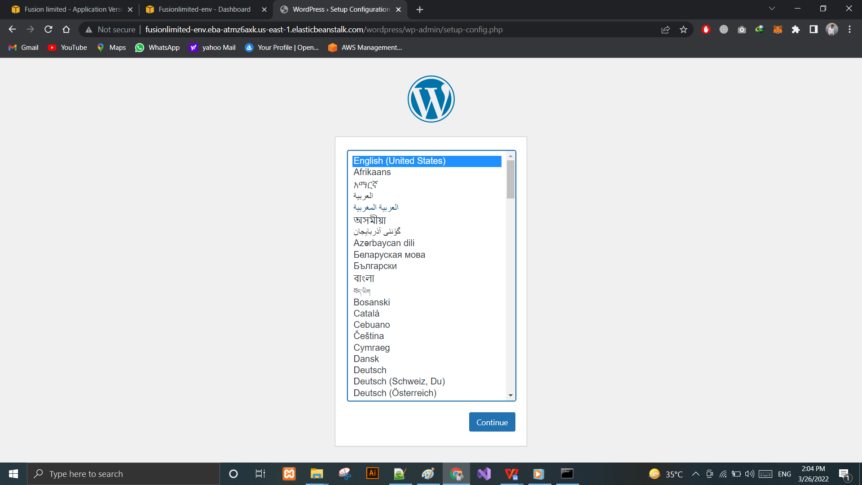

Screenshot: 31: Installation of Wordpress

The Site has been deployed and can be run on the AWS.

# References:

Amazon Documentation: Available at:

Link: https://docs.aws.amazon.com/

Abayomi-Zannu, Temidayo & Odun-Ayo, Isaac. (2019). Cloud Identity Management – A Critical Analysis.

Amazon Web Services, 2015. The Business Value of AWS Succeeding at Twenty-First Century Business Infrastructure. [Online] Available at: <https://d1.awsstatic.com/whitepapers/aws-whitepaper-business-value-of> aws.pdf

Amazon Web Services, 2020. Reliability PillarAWS Well-Architected Framework. [Online] Available at: <https://d1.awsstatic.com/whitepapers/architecture/AWS-Reliability-Pillar.pdf>

Chandrasekaran, K., 2015. Essentials of Cloud Computing. s.l.:CRC Press.

Dubrova, E., 2013. Fault-tolerant design. Berlin: Springer.

Eric Bauer, R. A., 2012. Reliability and Availability of Cloud Computing. s.l.:Wiley.

Kavis, M., 2014. Architecting the cloud Design decisions for cloud computing service models. s.l.:Wiley.

NIST SP 800-145, 2011. The NIST Definition of Cloud Computing. [Online]

Available at: http://csrc.nist.gov/publications/PubsSPs.html#800-145

Sharma, S., 2019. Making Application Failover Seamless by Failing Over Your Private Virtual IP Across Availability Zones. [Online] Available at: https://aws.amazon.com/blogs/apn/making-application-failover-seamless-by